* Java script:

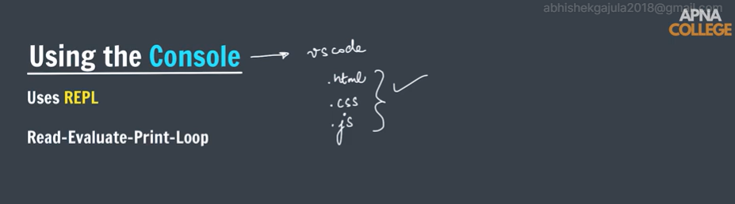

**What is JavaScript ?**

**JavaScript** is a *lightweight,* *cross-platform*, *single-threaded,*and *interpreted compiled* programming language. It is also known as the scripting language for webpages. It is well-known for the development of web pages, and many non-browser environments also use it.

JavaScript is a[**weakly typed language**](https://www.geeksforgeeks.org/type-systemsdynamic-typing-static-typing-duck-typing/)**(dynamically typed)**. JavaScript can be used for [**Client-side**](https://www.geeksforgeeks.org/server-side-client-side-programming/) developments as well as [**Server-side**](https://www.geeksforgeeks.org/server-side-client-side-programming/) developments. JavaScript is both an imperative and declarative type of language. JavaScript contains a standard library of objects, like [**Array**](https://www.geeksforgeeks.org/arrays-in-javascript/), [**Date**](https://www.geeksforgeeks.org/javascript-date-objects/), and [**Math**](https://www.geeksforgeeks.org/javascript-math-object/), and a core set of language elements like [**operators**](https://www.geeksforgeeks.org/javascript-operators/), **control structures**, and [**statements**](https://www.geeksforgeeks.org/javascript-statements/).

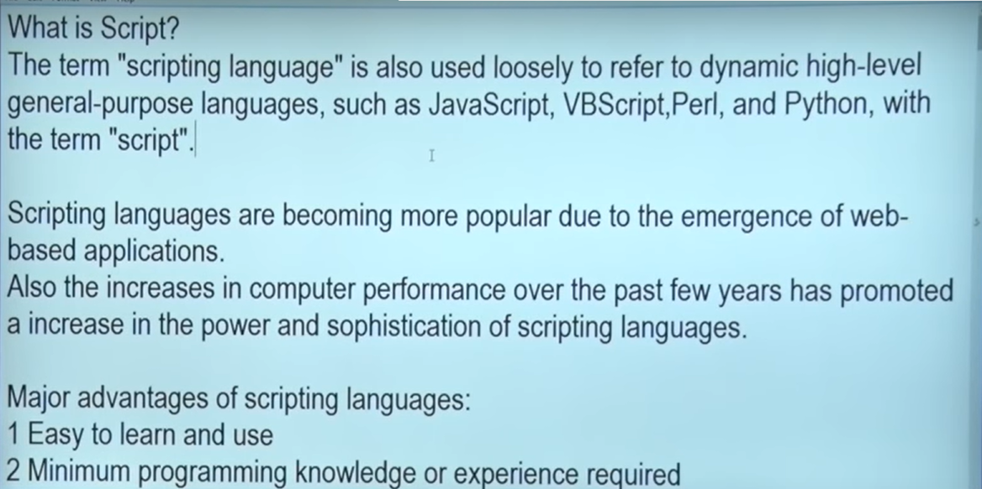

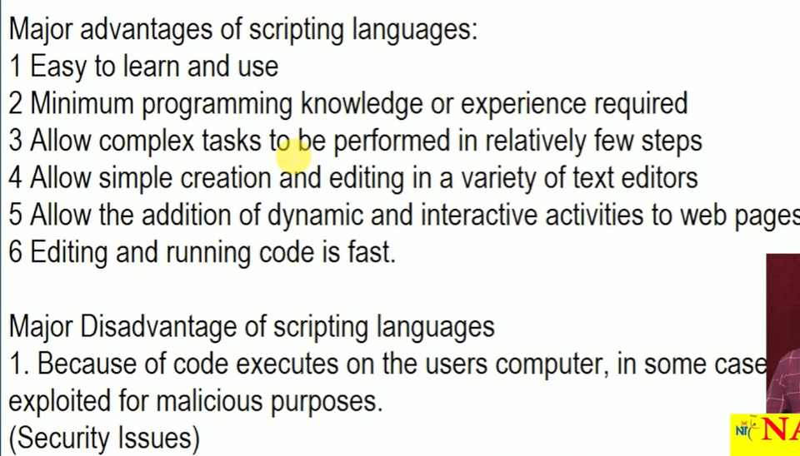

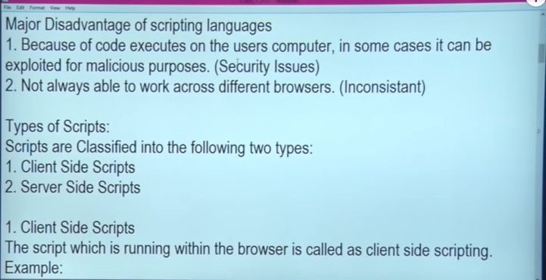

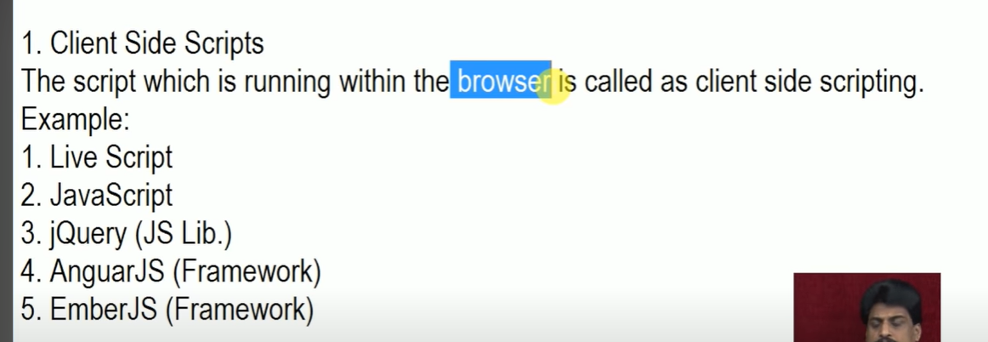

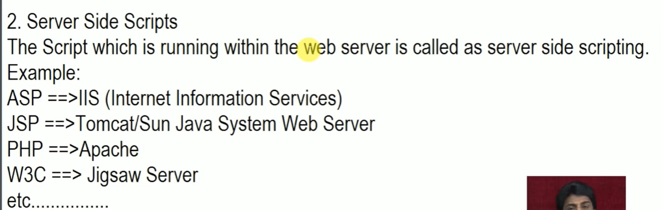

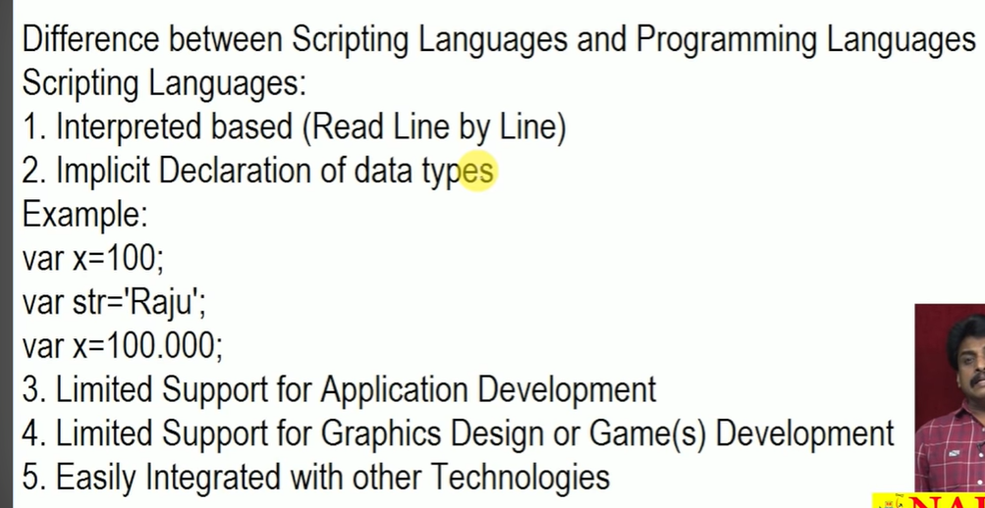

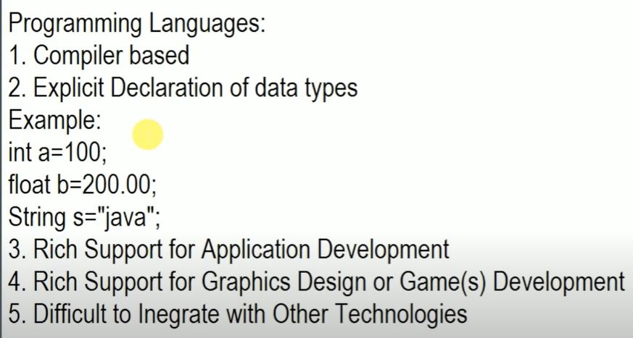

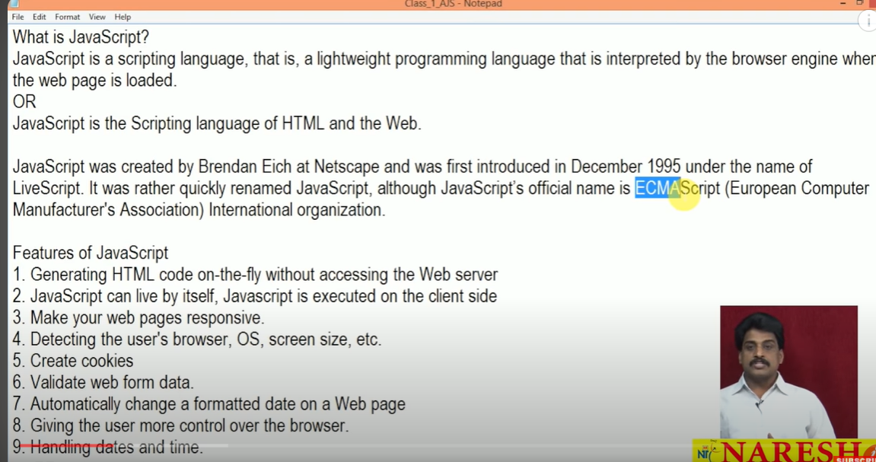

# Variables in js:

**Variables**are used to store data in JavaScript. Variables are used to store reusable values. The values of the variables are allocated using the assignment operator(“=”).

### JavaScript Assignment Operator

[JavaScript assignment operator](https://www.geeksforgeeks.org/javascript-assignment-operators/) is equal (=) which assigns the value of the right-hand operand to its left-hand operand.

y = "Geek"

### JavaScript Identifiers

JavaScript variables must have unique names. These names are called Identifiers.

#### **Basic rules to declare a variable in JavaScript:**

* These are case-sensitive
* Can only begin with a letter, underscore(“\_”) or “$” symbol
* It can contain letters, numbers, underscore, or “$” symbol
* A variable name cannot be a reserved keyword.

**JavaScript** is a dynamically typed language so the type of variables is decided at runtime. Therefore there is no need to explicitly define the type of a variable. We can declare variables in JavaScript in three ways:

* [**JavaScript var keyword**](https://www.geeksforgeeks.org/javascript-var/)
* [**JavaScript let keyword**](https://www.geeksforgeeks.org/javascript-let/)
* [**JavaScript const keyword**](https://www.geeksforgeeks.org/javascript-const/)

**Note:**In JavaScript, variables can be declared automatically.

**When to Use var, let, or const**

* We declare variables using const if the value should not be changed
* We use const if the type of the variables should not be changed such as working with Arrays and objects
* We should use let if we want mutable value or we can not use const
* We use var only if we support old browser.

**Syntax**

// Declaration using var

var geek = "Hello Geek"

// Declaration using let

let $ = "Welcome"

// Declaration using const

const \_example = "Gfg"

**Comparison of properties of let, var, and const keywords in JavaScript:**

| **Property** | **var** | **let** | **const** |
| --- | --- | --- | --- |
| [Scope](https://www.geeksforgeeks.org/javascript-scope/) | Function scoped | Block scoped | Block scoped |
| Updation | Mutable | Mutable | Immutable |
| Redeclaration | Can be redeclared | Cannot be redeclared | Cannot be redeclared |
| [Hoisting](https://www.geeksforgeeks.org/javascript-hoisting/) | Hoisted at top | Hoisted at top | Hoisted at top |
| Origins | Pre ES2015 | ES2015(ES6) | ES2015(ES6) |
| Support | Supported in the old version of Browser | Not supported in the old version of the Browser | Not supported in the old version of the Browser |

# JavaScript Data Types

**Primitive Data Types**

The predefined data types provided by JavaScript language are known as primitive data types. Primitive data types are also known as in-built data types.

* [**Number:**](https://www.geeksforgeeks.org/javascript-numbers/) JavaScript numbers are always stored in double-precision 64-bit binary format IEEE 754. Unlike other programming languages, you don’t need int, float, etc to declare different numeric values.
* [**String:**](https://www.geeksforgeeks.org/javascript-strings/) JavaScript Strings are similar to sentences. They are made up of a list of characters, which is essentially just an “array of characters, like “Hello GeeksforGeeks” etc.
* [**Boolean:**](https://www.geeksforgeeks.org/javascript-boolean/) Represent a logical entity and can have two values: true or false.
* [**Null:**](https://www.geeksforgeeks.org/null-in-javascript/) This type has only one value that is *null.*
* [**Undefined:**](https://www.geeksforgeeks.org/undefined-in-javascript/) A variable that has not been assigned a value is *undefined.*
* [**Symbol:**](https://www.geeksforgeeks.org/javascript-symbol-method/) Symbols return unique identifiers that can be used to add unique property keys to an object that won’t collide with keys of any other code that might add to the object.
* [**BigInt:**](https://www.geeksforgeeks.org/bigint-in-javascript/) BigInt is a built-in object in JavaScript that provides a way to represent whole numbers larger than 253-1.

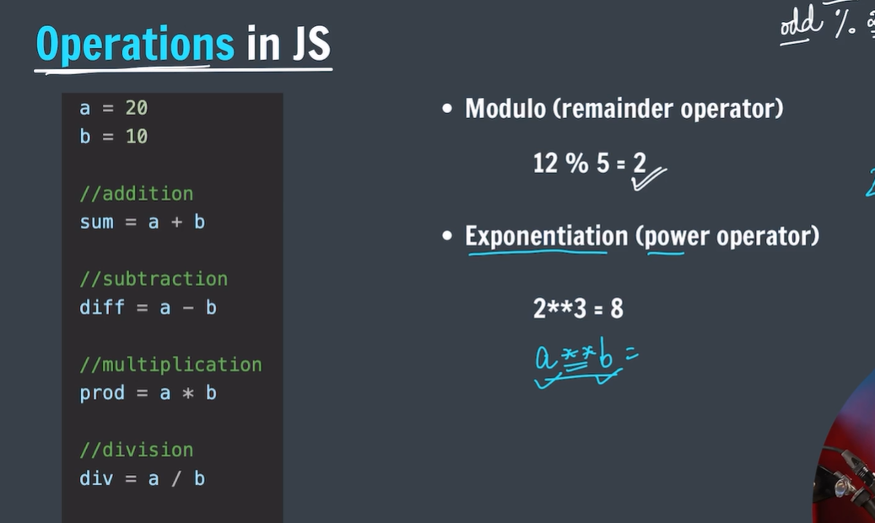

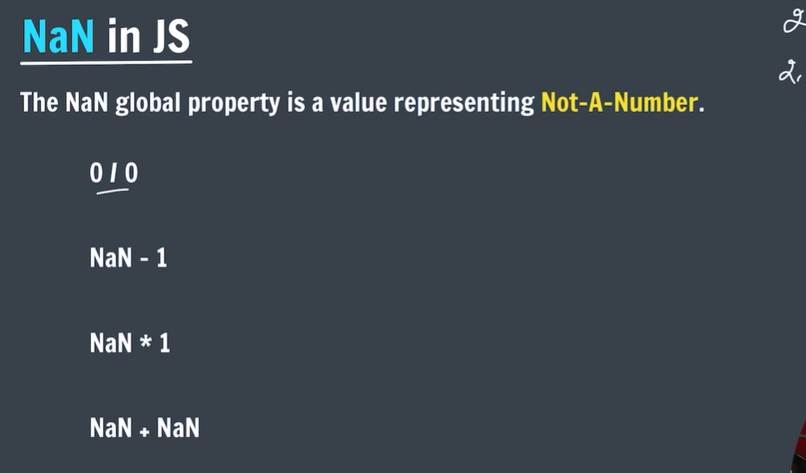

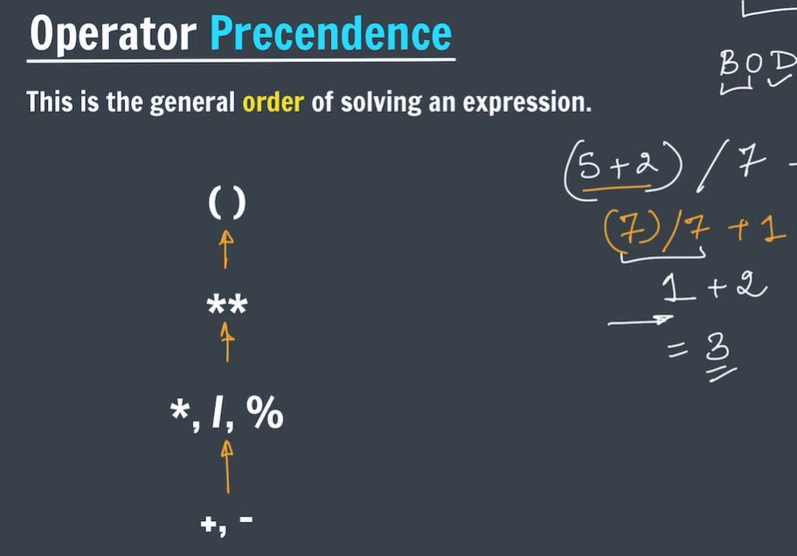

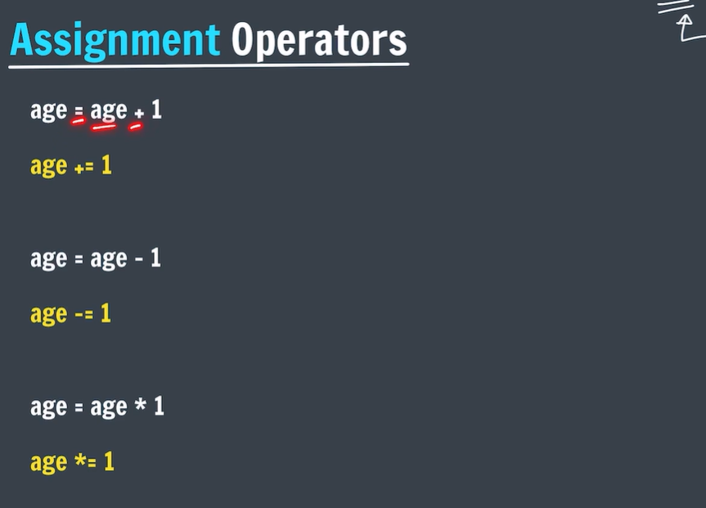

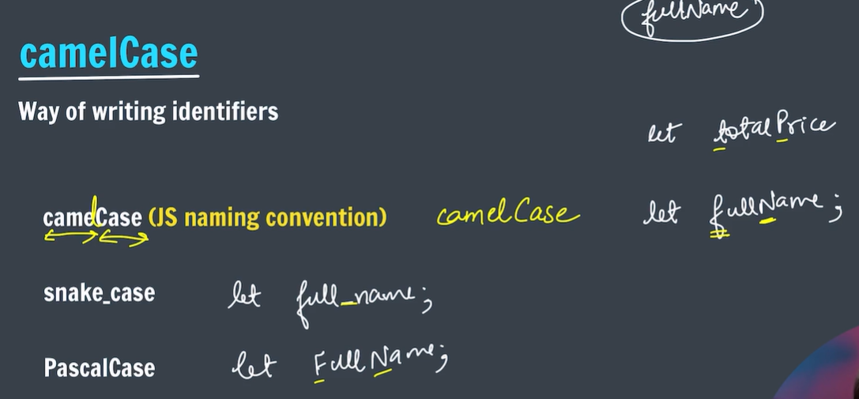

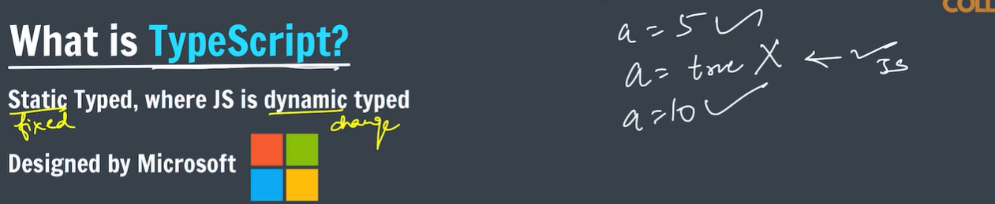

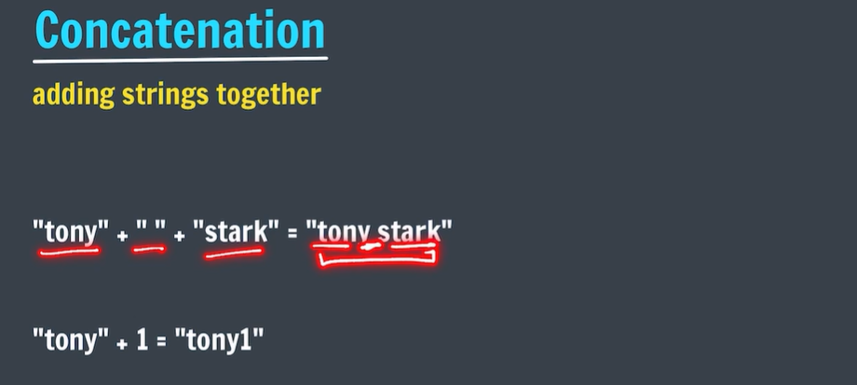

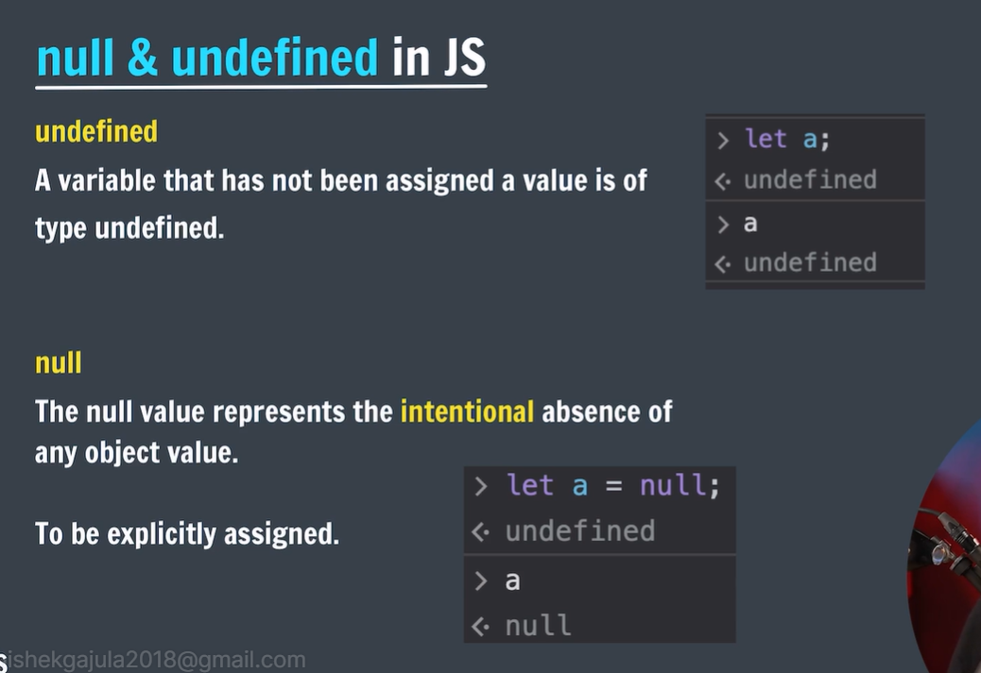

# Console in JavaScript

A **web console**is a tool that is mainly used to log information associated with a web page like, network requests, JavaScript, security errors, warnings, CSS, etc. It enables us to interact with a web page by executing JavaScript expressions in the contents of the page.

**JavaScript Console Methods:** The console object provides us with several different methods.

* [JS console.log() Method](https://www.geeksforgeeks.org/javascript-console-log-method/)
* [JS console.error() Method](https://www.geeksforgeeks.org/html-dom-console-error-method/)
* [JS console.warn() Method](https://www.geeksforgeeks.org/html-dom-console-warn-method/)
* [JS console.clear() Method](https://www.geeksforgeeks.org/html-dom-console-clear-method/)
* [JS console.time()](https://www.geeksforgeeks.org/html-dom-console-time-method/) and [console.timeEnd() Method](https://www.geeksforgeeks.org/html-dom-console-timeend-method/)
* [JS console.table() Method](https://www.geeksforgeeks.org/html-dom-console-table-method/)
* [JS console.count() Method](https://www.geeksforgeeks.org/html-dom-console-count-method/)
* [JS console.group()](https://www.geeksforgeeks.org/html-dom-console-group-method/) and [console.groupEnd() Method](https://www.geeksforgeeks.org/html-dom-console-groupend-method/)
* JS Custom console logs

[**JavaScript console.log() Method**](https://www.geeksforgeeks.org/javascript-console-log-method/)**:**It is used to log(print) the output to the console. We can put any type inside the log(), be it a string, array, object, boolean etc.

// console.log() method

console.log('abc');

console.log(1);

console.log(true);

console.log(null);

console.log(undefined);

console.log([1, 2, 3, 4]); // array inside log

console.log({a:1, b:2, c:3}); // object inside log

abc

1

true

null

undefined

(4)[1, 2, 3, 4]

{a: 1, b: 2, c: 3}

[**JavaScript console.error() Method**](https://www.geeksforgeeks.org/html-dom-console-error-method/)**:**This method is used to log an error message to the console. Useful in testing of code. By default the error message will be highlighted with red color.

// console.error() method

console.error('This is a simple error');

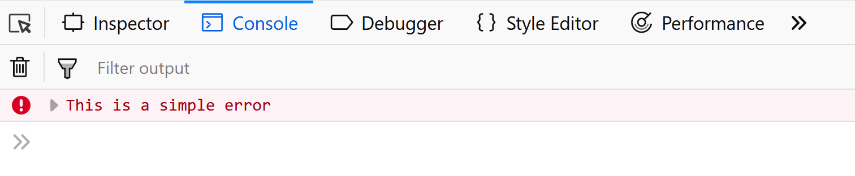

[**JavaScript console.warn() Method**](https://www.geeksforgeeks.org/html-dom-console-warn-method/)**:**Used to log warning message to the console. By default, the warning message will be highlighted with yellow color.

// console.warn() method

console.warn('This is a warning.');

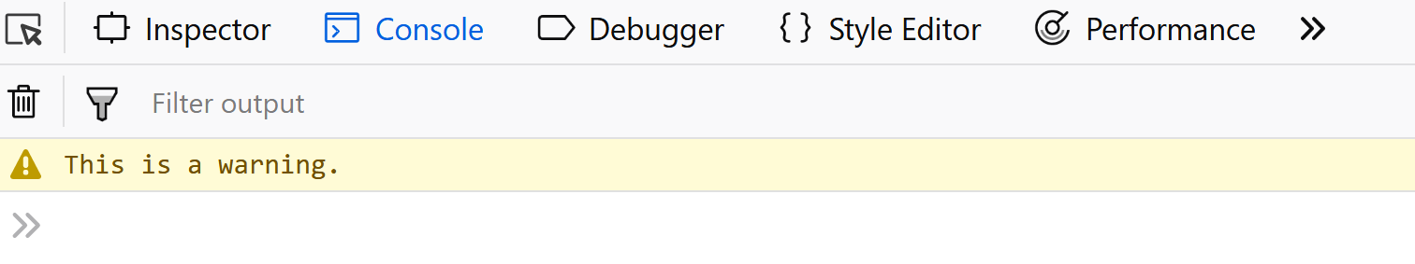

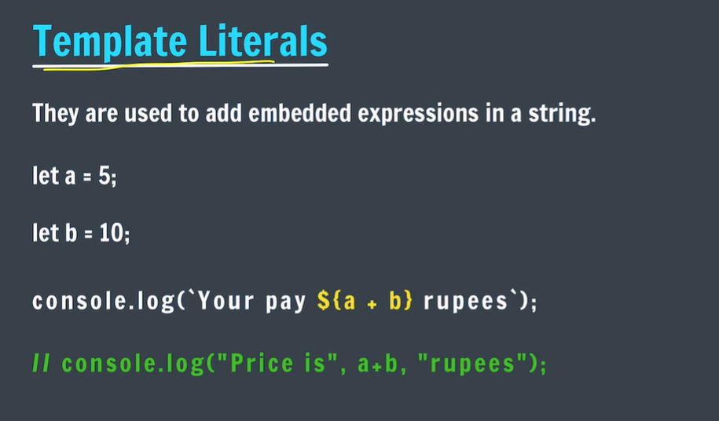

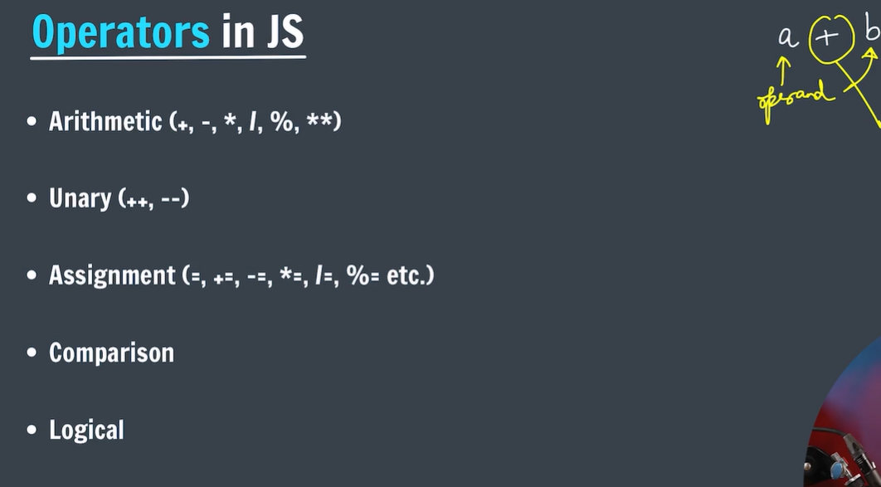

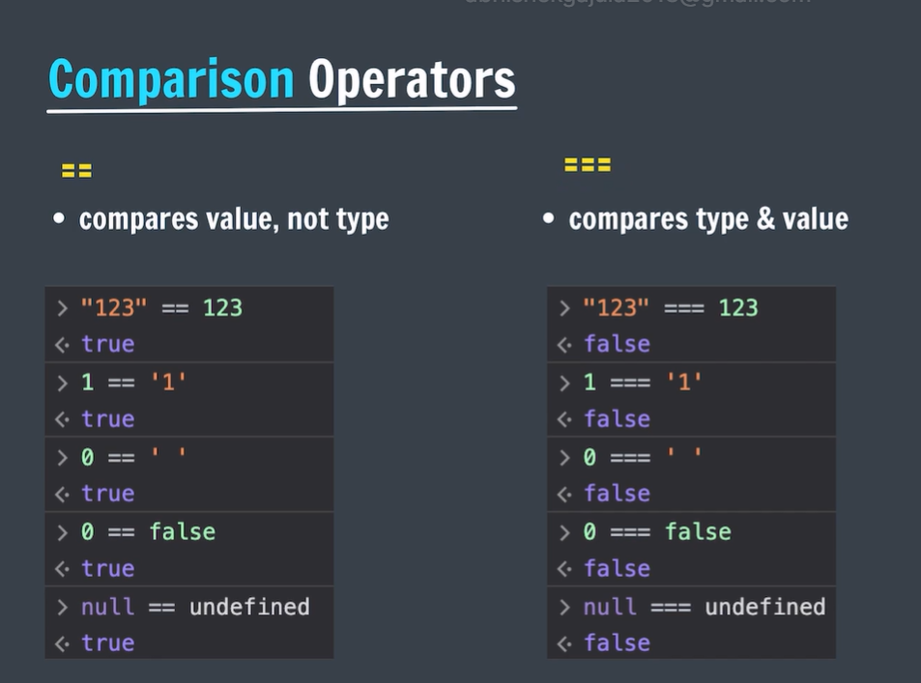

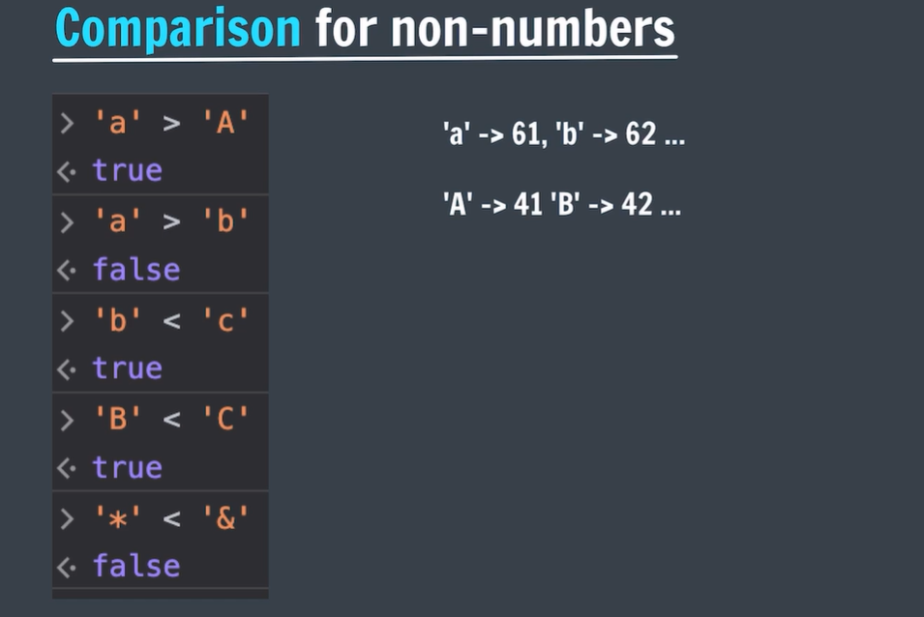

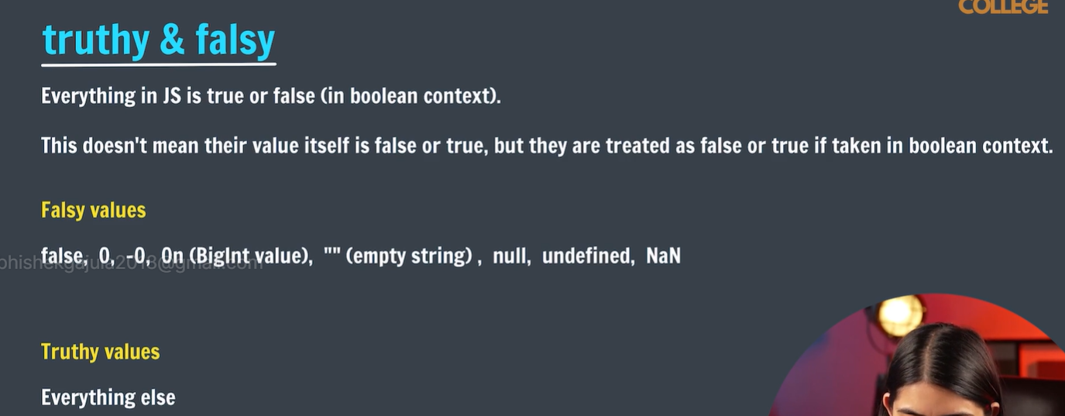

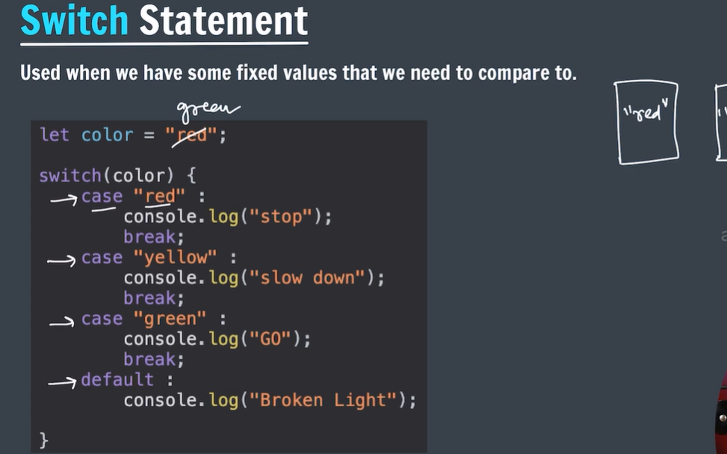

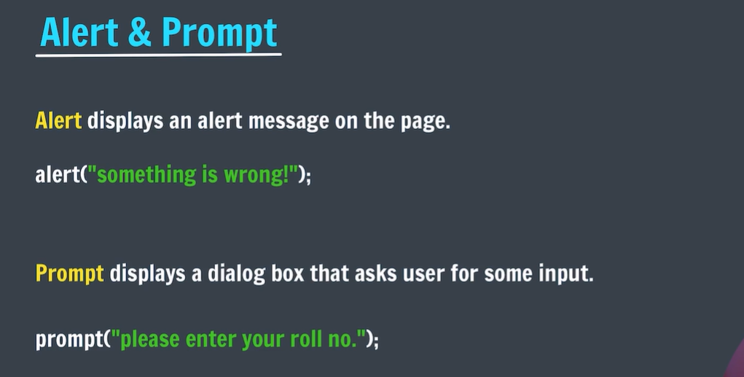

# JavaScript String Methods

**JavaScript strings** are the sequence of characters. They are treated as **Primitive data types**. In JavaScript, strings are automatically converted to string objects when using **string methods** on them. This process is called **auto-boxing.**

## ****JavaScript slice() Method****

[JavaScript slice method](https://www.geeksforgeeks.org/javascript-string-slice/) extracts a part of the string based on the given stating-index and ending-index and returns a new string.

// Define a string variable

let A = 'Geeks for Geeks';

// Use the slice() method to extract a substring

let b = A.slice(0, 5);

let c = A.slice(6, 9);

let d = A.slice(10);

// Output the value of variable

console.log(b);

console.log(c);

console.log(d);

Geeks

for

Geeks

## ****JavaScript trim() Method****

[**JavaScript trim() method**](https://www.geeksforgeeks.org/javascript-string-prototype-trim-function/) is used to remove either white spaces from the given string. This method returns a new string with removed white spaces.

let gfg = 'GFG ';

let geeks = 'stands-for-GeeksforGeeks';

// Storing new object of string

// with removed white spaces

let newGfg = gfg.trim();

// Old length

console.log(gfg.length);

// New length

console.log(newGfg.length)

7

3

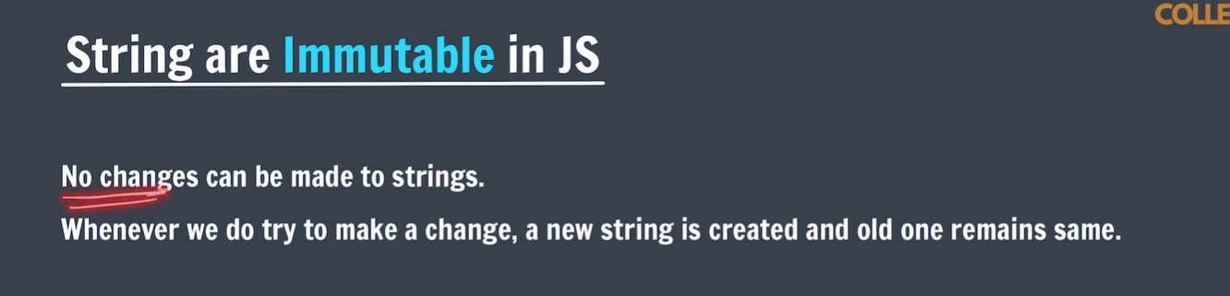

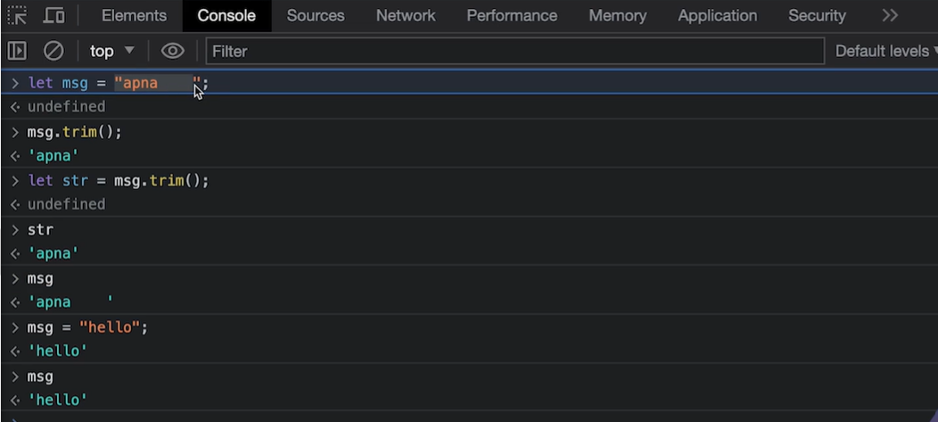

## ****JavaScript toUpperCase()****

[**JavaScript toUpperCase() method**](https://www.geeksforgeeks.org/javascript-string-touppercase/) converts all the characters present in the String to upper case and returns a new String with all characters in upper case. This method accepts single parameter **stringVariable** string that you want to convert in upper case.

// Define a string variable

let gfg = 'GFG ';

// Define another string variable

let geeks = 'stands-for-GeeksforGeeks';

// Convert the string 'geeks' to uppercase using the toUpperCase() method

console.log(geeks.toUpperCase());

**Output**

STANDS-FOR-GEEKSFORGEEKS

## ****JavaScript toLowerCase()****

[**JavaScript toLowerCase() method**](https://www.geeksforgeeks.org/javascript-string-prototype-tolowercase/) converts all the characters present in the so lowercase and returns a new string with all the characters in lowercase.

// Define a string variable

let gfg = 'GFG ';

// Define a string variable

let geeks = 'stands-for-GeeksforGeeks';

// Convert the string 'geeks' to lowercase using the toLowerCase() method

console.log(geeks.toLowerCase());

**Output**

stands-for-geeksforgeeks

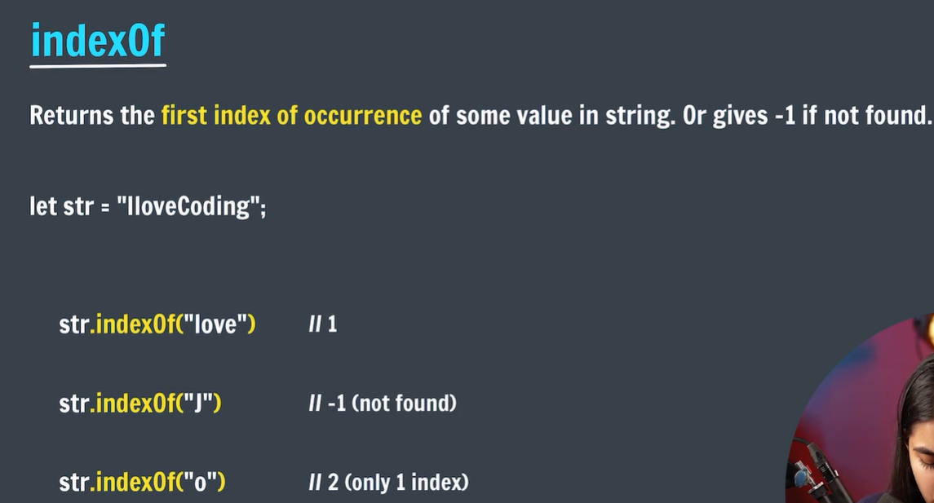

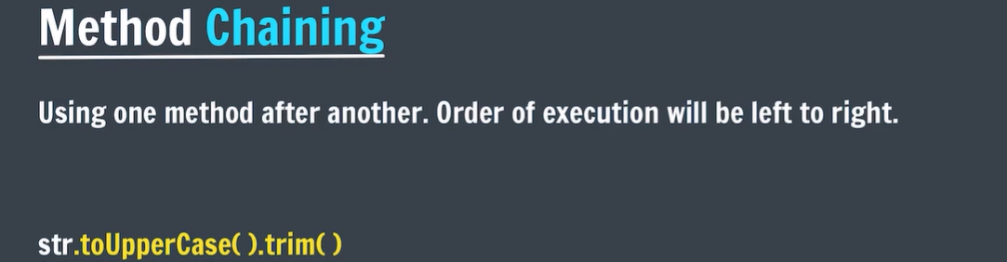

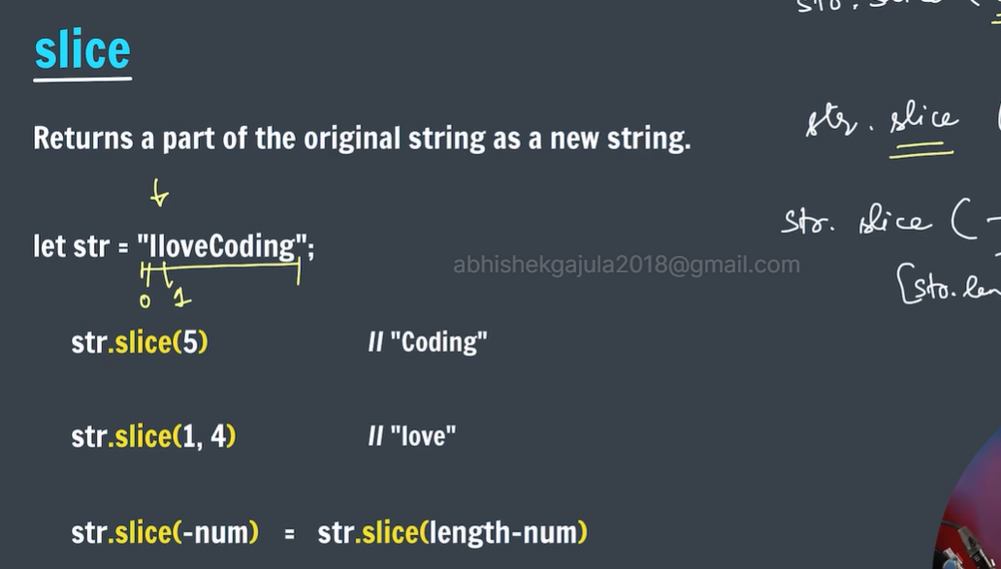

// Define a string variable

let A = 'Geeks for Geeks';

// Use the slice() method to extract a substring

let b = A.slice(0, 5);

let c = A.slice(6, 9);

let d = A.slice(10);

// Output the value of variable

console.log(b);

console.log(c);

console.log(d);

**Output**

Geeks

for

Geeks

## ****JavaScript replace()****

[**JavaScript replace() method**](https://www.geeksforgeeks.org/javascript-string-replace-method/)replaces a part of the given string with another string or a regular expression. The original string will remain unchanged.

// Define a string variable 'str'

let str = "Mind, Power, Soul";

// Use the replace() method to replace the substring

let part = str.replace("Power", "Space");

// Output the resulting string after replacement

console.log(part);

**Output**

Mind, Space, Soul

Note:this method only replaces only the first occurrence of the given sub string.to replace the all the occurrences of the given sub string we should use **replaceAll();**

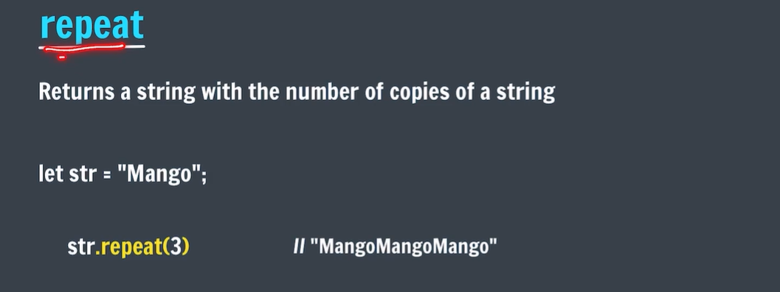

# JavaScript Arrays

## What is Array in JavaScript?

**JavaScript Array** is a data structure that allows you to store and organize multiple values within a single variable. It is a versatile and dynamic object. It can hold various data types, including numbers, strings, objects, and even other arrays. Arrays in JavaScript are zero-indexed i.e. the first element is accessed with an index 0, the second element with an index of 1, and so forth.

## ****Declaration of an Array****

### **1. Creating an Array using Array Literal**

let arrayName = [value1, value2, ...];

// Creating an Empty Array

let names = [];

console.log(names);

// Creating an Array and Initializing with Values

let courses = ["HTML", "CSS", "Javascript", "React"];

console.log(courses);

[]

[ 'HTML', 'CSS', 'Javascript', 'React' ]

### **2. Creating an Array using Array Constructor (JavaScript new Keyword)**

let arrayName = new Array();

// Declaration of an empty array

// using Array constructor

let names = new Array();

console.log(names);

// Creating and Initializing an array with values

let courses = new Array("HTML", "CSS", "Javascript", "React");

console.log(courses);

// Initializing Array while declaring

let arr = new Array(3);

arr[0] = 10;

arr[1] = 20;

arr[2] = 30;

console.log(arr);

**Output**

[]

[ 'HTML', 'CSS', 'Javascript', 'React' ]

[ 10, 20, 30 ]

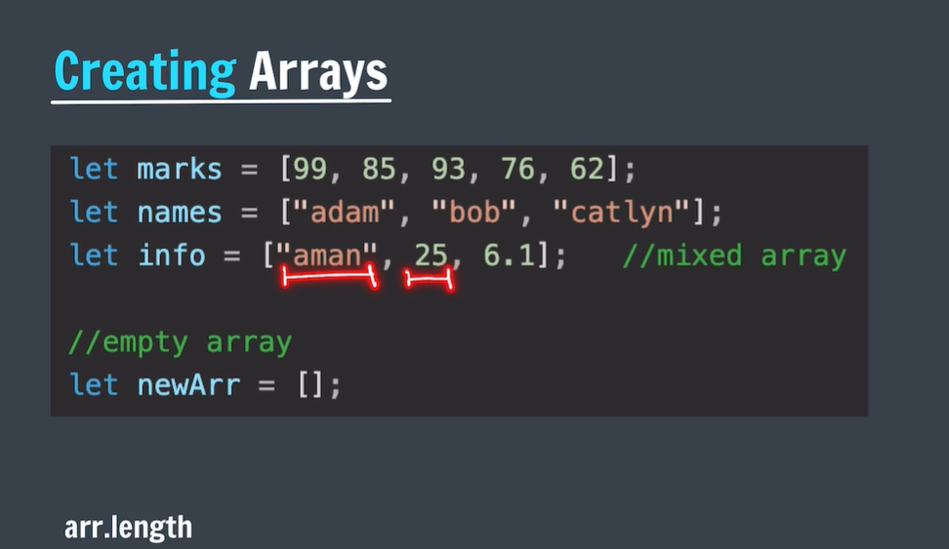

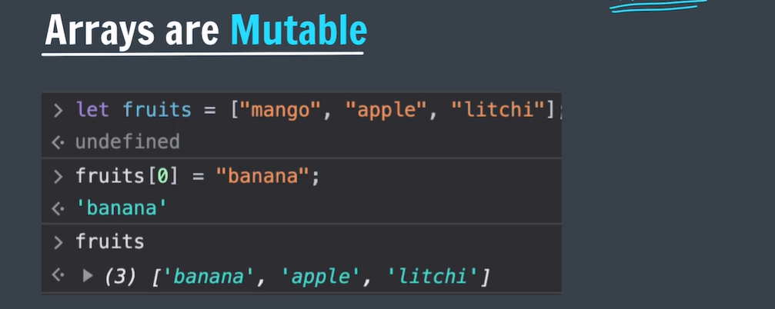

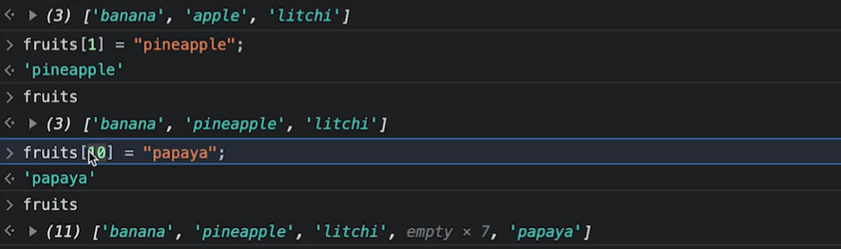

## Basic Operations on JavaScript Arrays

### Adding Elements to the Array

Elements can be added to the array using methods like push() and unshift().

// Creating an Array and Initializing with Values

let courses = ["HTML", "CSS", "Javascript", "React"];

// Add Element to the end of Array

courses.push("Node.js");

// Add Element to the beginning

courses.unshift("Web Development");

console.log(courses);

**Output**

[ 'Web Development', 'HTML', 'CSS', 'Javascript', 'React', 'Node.js' ]

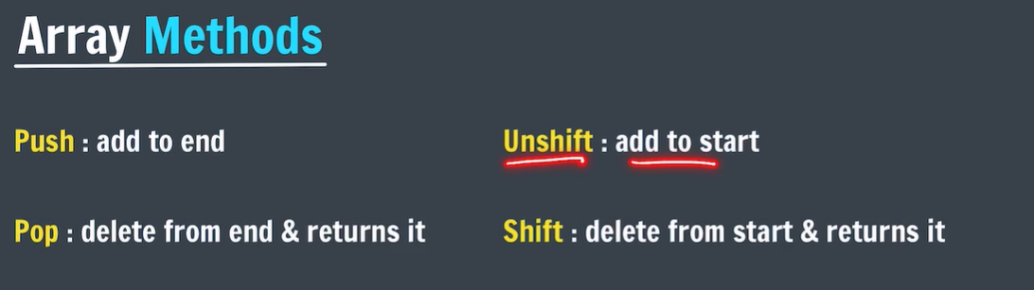

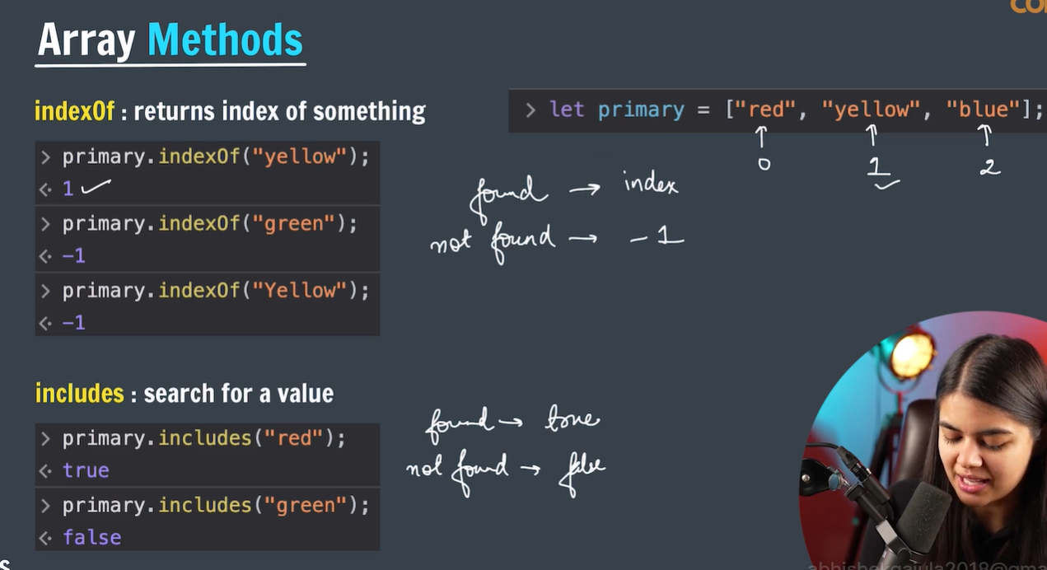

### Array Concatenation

Combine two or more arrays using the concat() method. Ir returns new array conaining joined arrays elements.

// Creating an Array and Initializing with Values

let courses = ["HTML", "CSS", "JavaScript", "React"];

let otherCourses = ["Node.js", "Expess.js"];

// Concatenate both arrays

let concateArray = courses.concat(otherCourses);

console.log("Concatenated Array: ", concateArray);

**Output**

Concatenated Array: [ 'HTML', 'CSS', 'JavaScript', 'React', 'Node.js', 'Expess.js' ]

### **Conversion of an Array to String**

We have a builtin method **[toString()](https://www.geeksforgeeks.org/javascript-array-tostring-method/" \t "_blank)**to converts an array to a string.

// Creating an Array and Initializing with Values

let courses = ["HTML", "CSS", "JavaScript", "React"];

// Convert array ot String

console.log(courses.toString());

**Output**

HTML,CSS,JavaScript,React

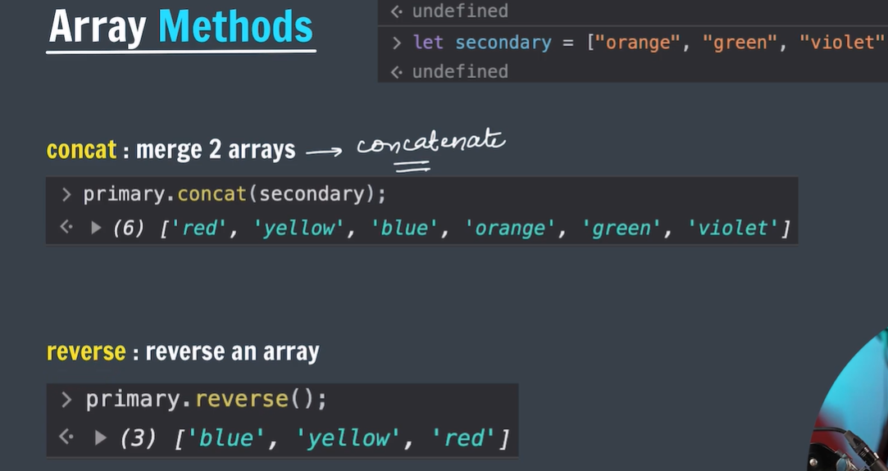

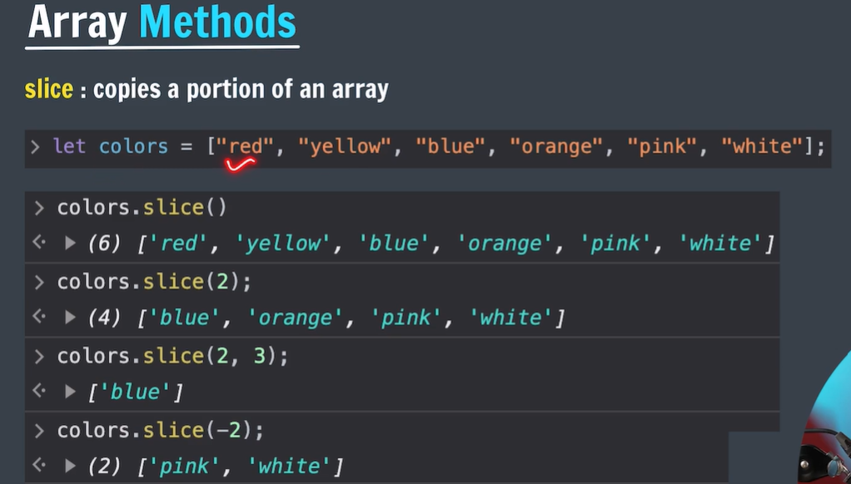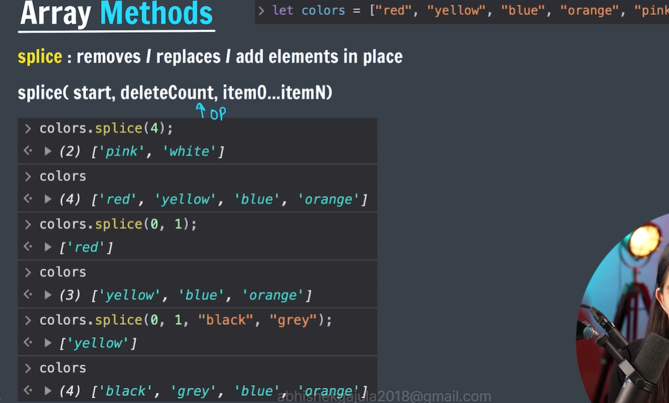

# JavaScript Array sort() Method

The **sort() method** in JavaScript arranges the elements of an array in place and returns the sorted array. By default, it sorts the elements alphabetically as strings. If numerical sorting is required, a custom comparison function can be provided as an argument.

## ****Array sort() Method Syntax****

arr.sort(compareFunction);

### Sorting an array of strings

// JavaScript to illustrate sort() function

function func() {

// Original string

let arr = ["Geeks", "for", "Geeks"]

console.log(arr);

// Sorting the array

console.log(arr.sort());

}

func();

[ 'Geeks', 'for', 'Geeks' ]

[ 'Geeks', 'Geeks', 'for' ]

let numbers = [20, 5.2, -120, 100, 30, 0]

console.log(numbers.sort())

[ -120, 0, 100, 20, 30, 5.2 ]

Here’s what happens with your array:

* The numbers are converted to strings: ["20", "5.2", "-120", "100", "30", "0"].
* When sorted alphabetically, -120 comes first because - has a lower Unicode code point value than digits (0 to 9). Then comes 0, followed by 100, 20, 30, and 5.2.

### Const in Arrays

**Example:** It describes that the array values can be modified only reference to the array cannot be changed.

// Changing the content of array is

// possible in cost array

const arr1 = ["pankaj", "sumit", "chandan", "ajay"];

console.log(arr1.toString());

arr1[2] = "Narayan"; // possible

console.log(arr1.toString());

**Output**

pankaj,sumit,chandan,ajay

pankaj,sumit,Narayan,ajay

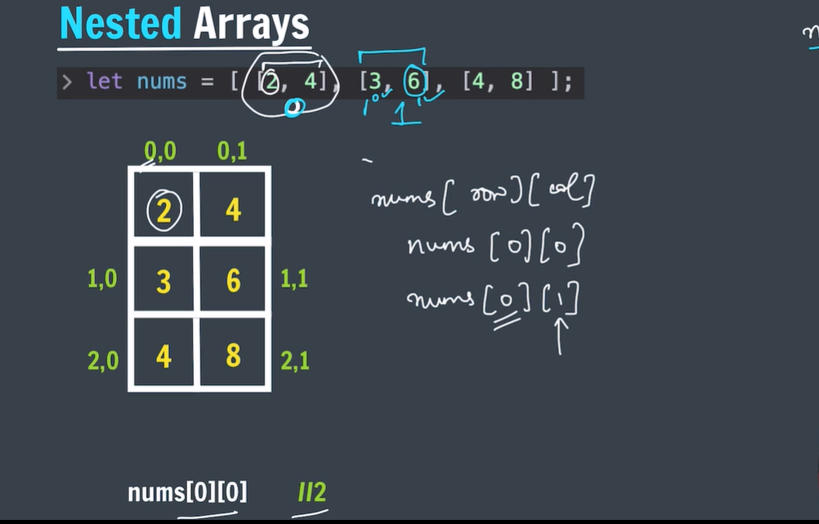

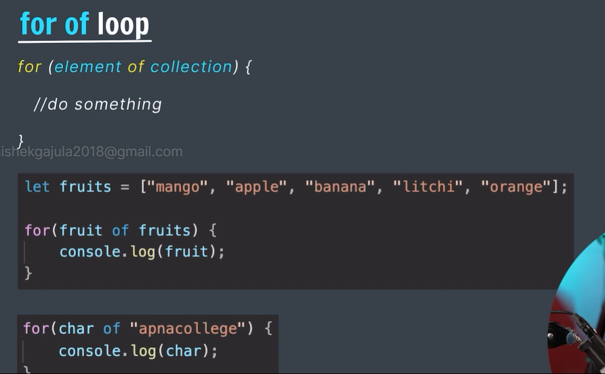

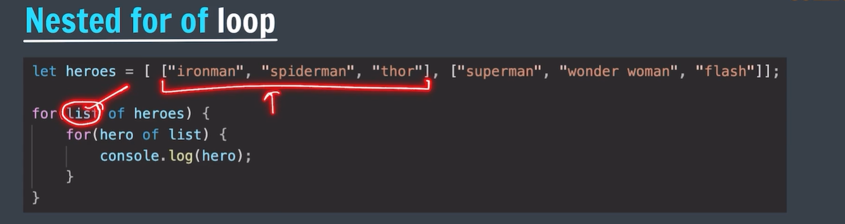

# Object literals:

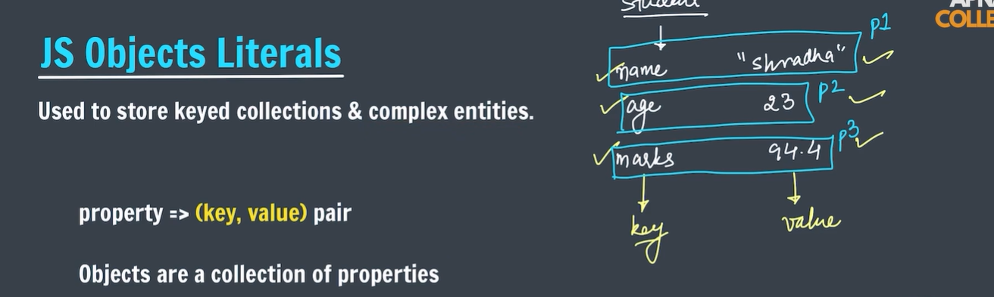

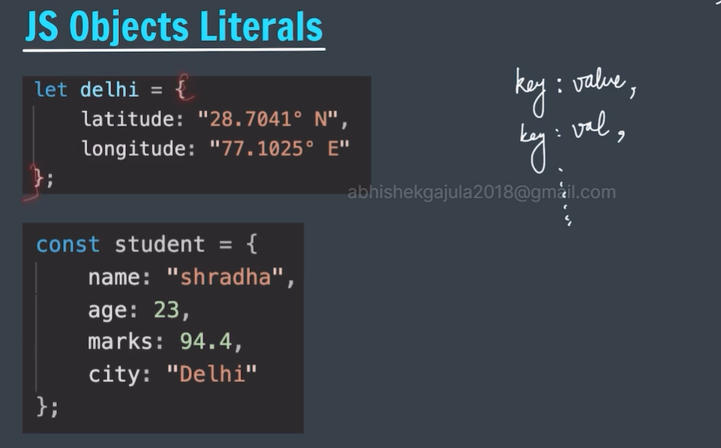

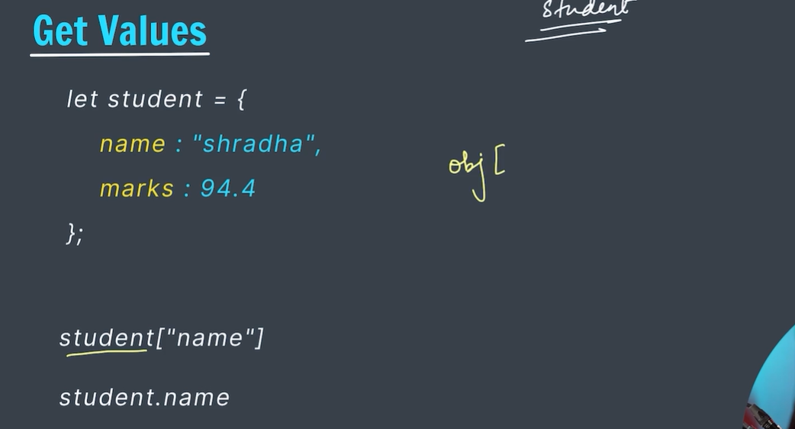

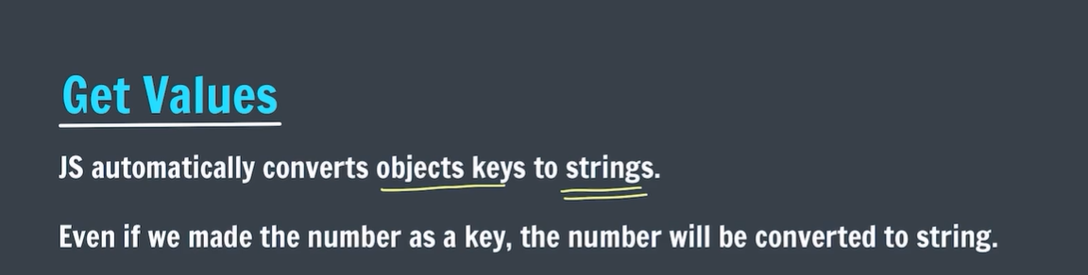

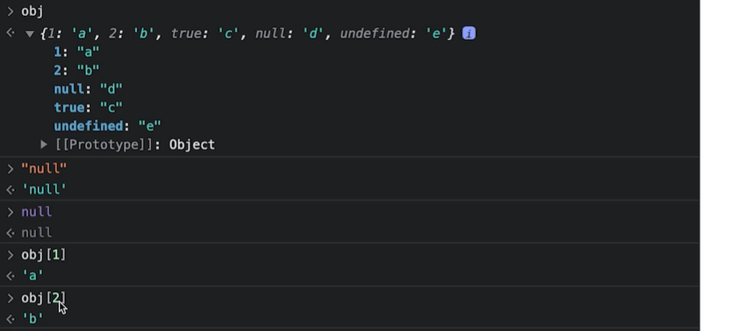

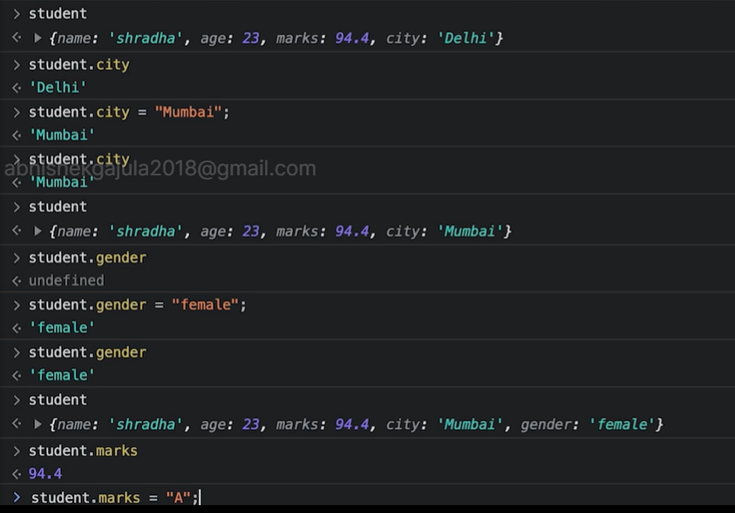

* To delete the property 🡪 delete objectliteral<name>.key;

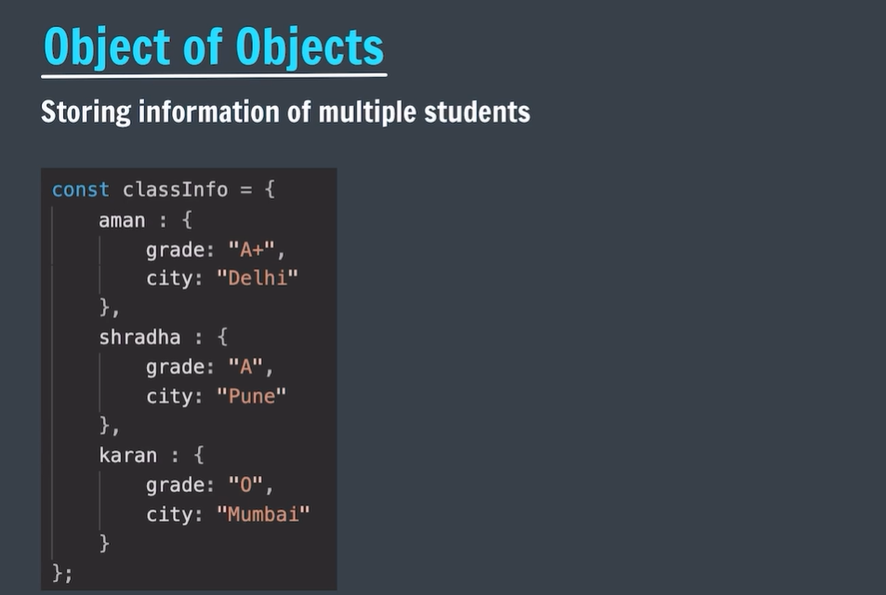

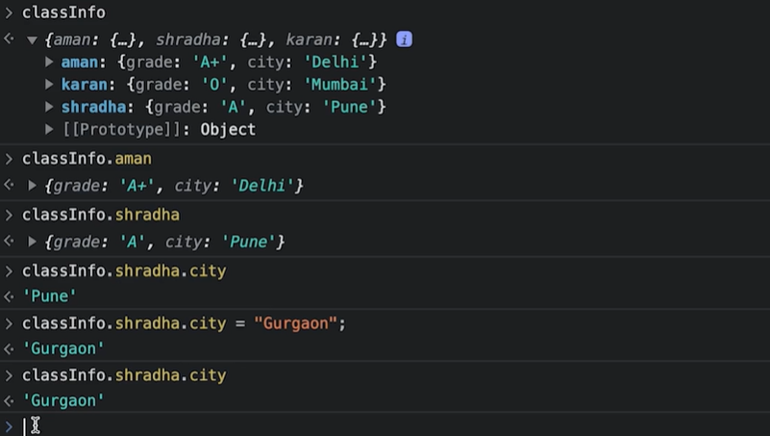

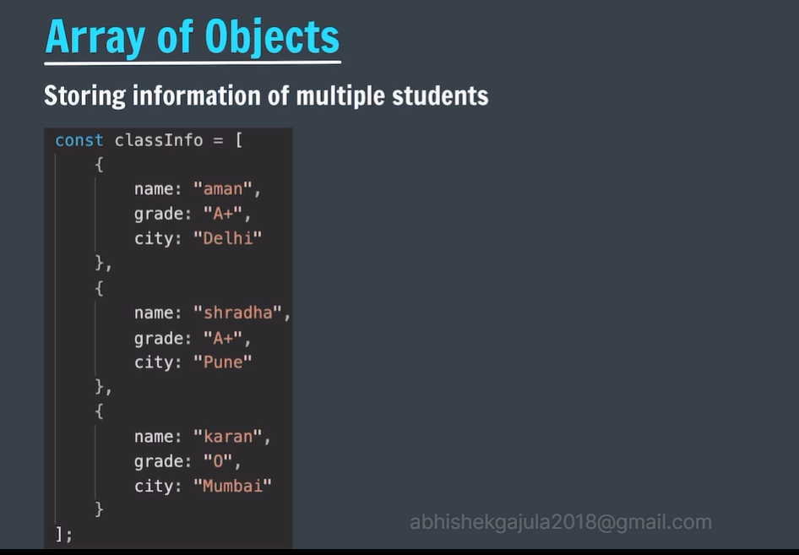

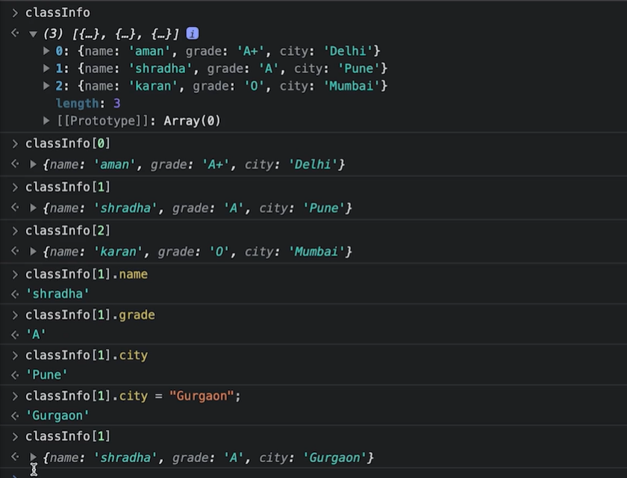

# Math object:

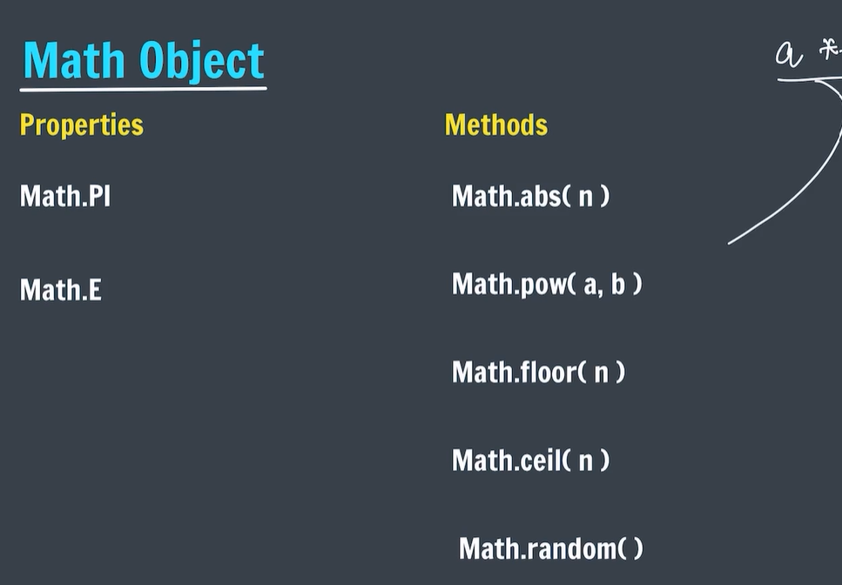

## Math Properties (Constants)

The syntax for any Math property is : Math.*property*.

JavaScript provides 8 mathematical constants that can be accessed as Math properties:

### **Example**

Math.E        // returns Euler's number  
Math.PI       // returns PI  
Math.SQRT2    // returns the square root of 2  
Math.SQRT1\_2  // returns the square root of 1/2  
Math.LN2      // returns the natural logarithm of 2  
Math.LN10     // returns the natural logarithm of 10  
Math.LOG2E    // returns base 2 logarithm of E  
Math.LOG10E   // returns base 10 logarithm of E

## Math Methods

The syntax for Math any methods is : Math.*method*(*number*)

## Number to Integer

There are 4 common methods to round a number to an integer:

|  |
| --- |
|  |
| Math.round(x) | Returns x rounded to its nearest integer |
|  |  |
| Math.ceil(x) | Returns x rounded up to its nearest integer |
|  |  |
| Math.floor(x) | Returns x rounded down to its nearest integer |
|  |  |
| Math.trunc(x) | Returns the integer part of x ([new in ES6](https://www.w3schools.com/js/js_es6.asp)) |

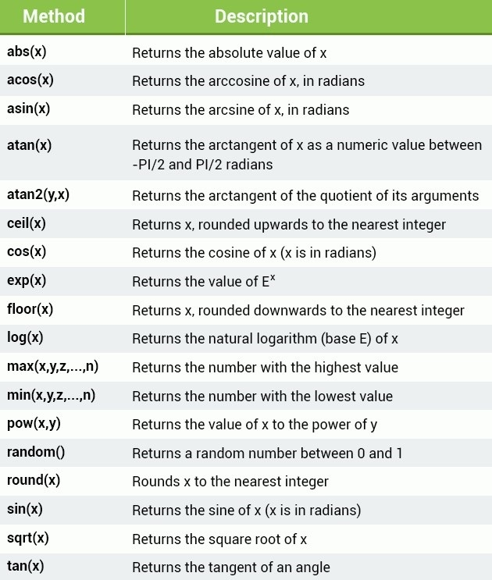

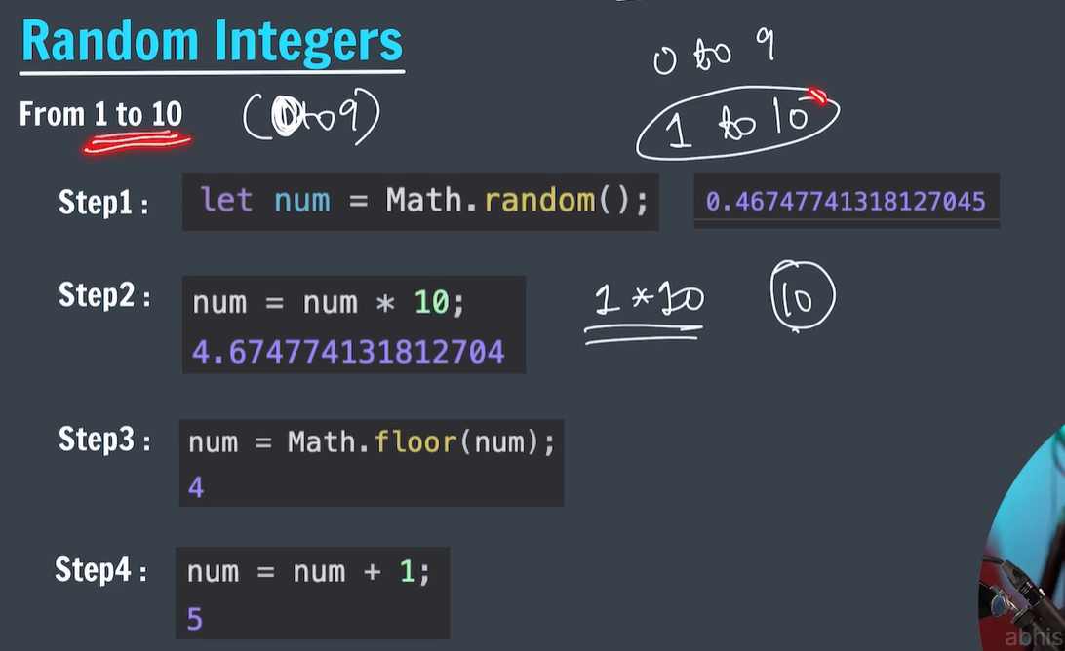

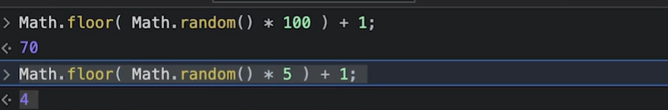

# Functions in JavaScript

JavaScript **function**is a set of statements that take inputs, do some specific computation, and produce output.

A JavaScript function is executed when “something” invokes it (calls it).

function myFunction(g1, g2) {

return g1 / g2;

}

const value = myFunction(8, 2); // Calling the function

console.log(value);

function functionName(Parameter1, Parameter2, ...)  
{  
 // Function body  
}

## [****Function Expression:****](https://www.geeksforgeeks.org/javascript-function-expression/)

It is similar to a function declaration without the function name. Function expressions can be stored in a variable assignment.

**Syntax:**

let geeksforGeeks= function(paramA, paramB) {  
 // Set of statements  
}

const square = function (number) {

return number \* number;

};

const x = square(4); // x gets the value 16

console.log(x);

**Output**

16

Scope determines the accessibility (visibility) of variables.

JavaScript variables have 3 types of scope:

* Block scope
* Function scope
* Global scope

## Block Scope

Before ES6 (2015), JavaScript variables had only **Global Scope** and **Function Scope**.

ES6 introduced two important new JavaScript keywords: let and const.

These two keywords provide **Block Scope** in JavaScript.

Variables declared inside a { } block cannot be accessed from outside the block:

{  
  let x = 2;  
}  
// x can NOT be used here

Variables declared with the var keyword can NOT have block scope.

Variables declared inside a { } block can be accessed from outside the block.

### **Example**

{  
  var x = 2;  
}  
// x CAN be used here

## Local Scope

Variables declared within a JavaScript function, are **LOCAL** to the function:

### **Example**

// code here can NOT use carName  
  
function myFunction() {  
  let carName = "Volvo";  
  // code here CAN use carName  
}  
  
// code here can NOT use carName

[Try it Yourself »](https://www.w3schools.com/js/tryit.asp?filename=tryjs_scope_local)

**Local** variables have **Function Scope**:

They can only be accessed from within the function.

## Function Scope

JavaScript has function scope: Each function creates a new scope.

Variables defined inside a function are not accessible (visible) from outside the function.

Variables declared with var, let and const are quite similar when declared inside a function.

They all have **Function Scope**:

## Global Scope

Variables declared **Globally** (outside any function) have **Global Scope**.

**Global** variables can be accessed from anywhere in a JavaScript program.

Variables declared with var, let and const are quite similar when declared outside a block.

They all have **Global Scope**:

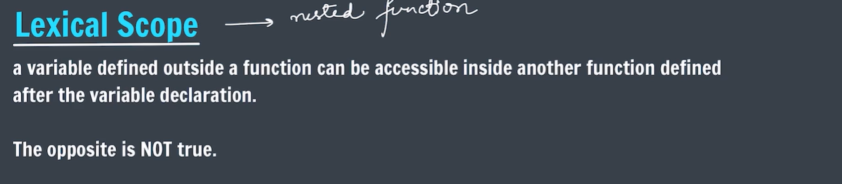

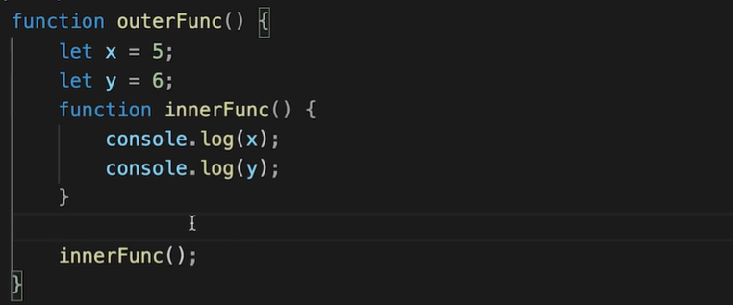

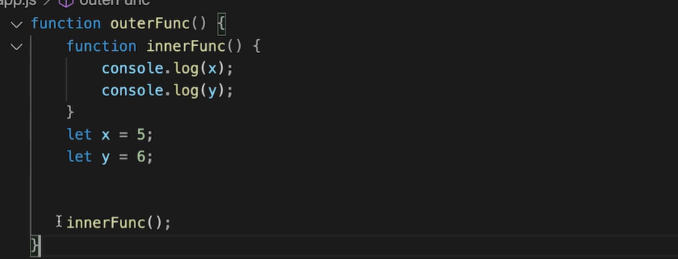

* The above one is also works by using hoisting technique.

# JavaScript Higher Order Functions

* In JavaScript, a higher-order function is a function that can accept other functions as arguments, return functions, or both. They enable abstraction, composition, and the creation of more flexible and reusable code.
* **Syntax:**
* function higherOrderFunction(callback) {  
   // Perform some operations  
   // Call the callback function  
   callback();  
  }  
  function callbackFunction() {  
   console.log("Callback function is executed.");  
  }  
  // Passing the callback function to the higher-order function  
  higherOrderFunction(callbackFunction);

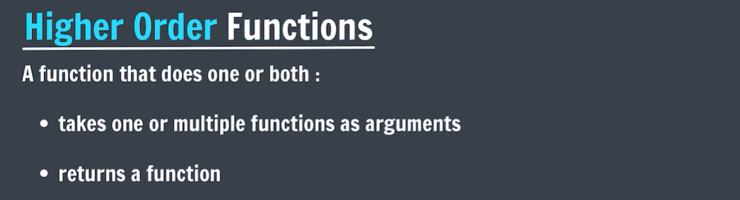

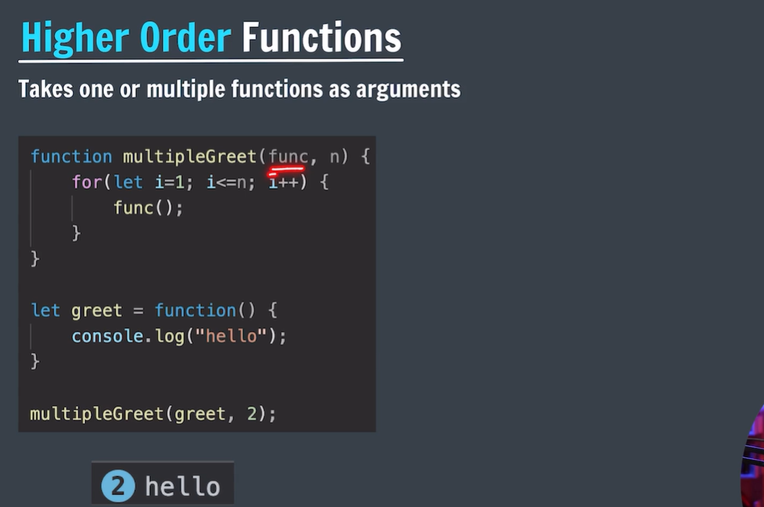

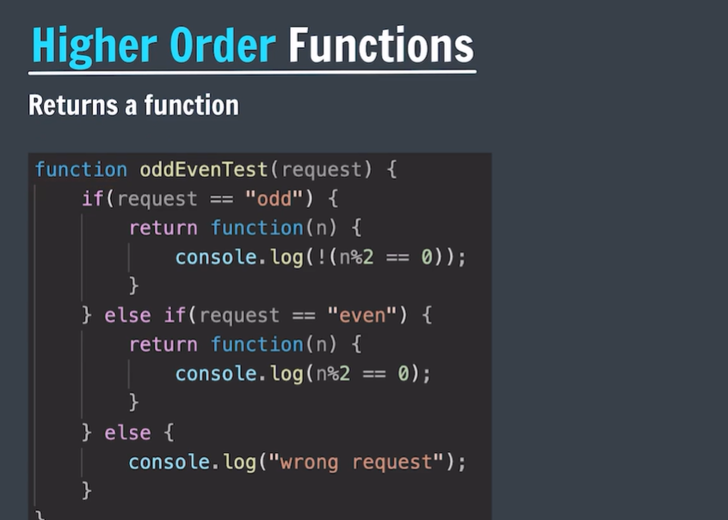

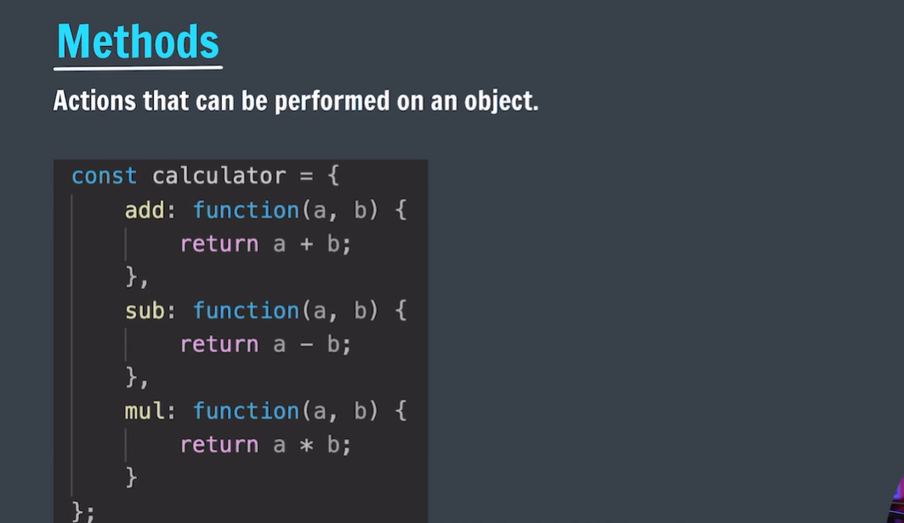

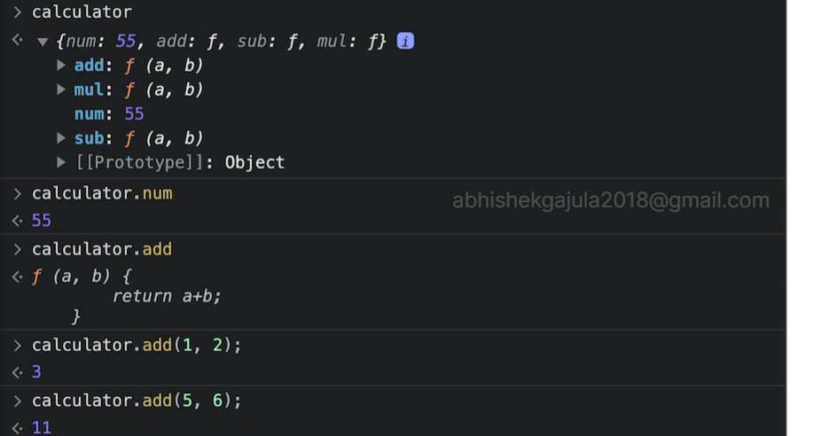

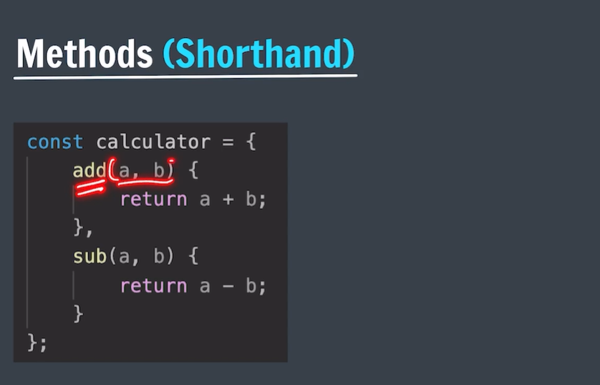

# JavaScript this Keyword

In **JavaScript, this keyword** refers to the**current context or scope** within which code is executing. Its value is determined by how a function is called, and it can dynamically change depending on the invocation context.

The **this keyword** refers to different objects depending upon how it is used:

* When used within a method of an object, this points to that object.
* When used by itself, this points to the global object.
* Within a function, this typically points to the global object.
* In a function under strict mode, this becomes undefined.
* During an event, this points to the element that triggered the event.
* Methods such as call(), apply(), and bind() can reassign this to any desired object.

const person = {

name: 'John',

age: 30,

greet() {

console.log('Hello, my name is ' + this.name + ' and I am ' + this.age + ' years old.');

}

};

person.greet(); // Output: Hello, my name is John and I am 30 years old.

Hello, my name is John and I am 30 years old.

function greet() {

console.log('Hello, my name is ' + this.name);

}

const person = {

name: 'John',

sayHello: greet

};

const anotherPerson = {

name: 'Alice'

};

greet(); // Output: Hello, my name is undefined

person.sayHello(); // Output: Hello, my name is John

greet.call(anotherPerson); // Output: Hello, my name is Alice

Hello, my name is undefined

Hello, my name is John

Hello, my name is Alice

# JavaScript Errors Throw and Try to Catch

When executing JavaScript code, errors will definitely occur. These errors can occur due to a fault from the programmer’s side or the input is wrong or even if there is a problem with the logic of the program.

But all errors can be solved and to do so we use five statements that will now be explained.

* The **try** statement lets you test a block of code to check for errors.
* The **catch** statement lets you handle the error if any are present.
* The **throw** statement lets you make your own errors.
* The **finally** statement lets you execute code after try and catch.    
  The **finally**block runs regardless of the result of the try-catch block.

try {

dadalert("Welcome Fellow Geek!");

}

catch (err) {

console.log(err);

}

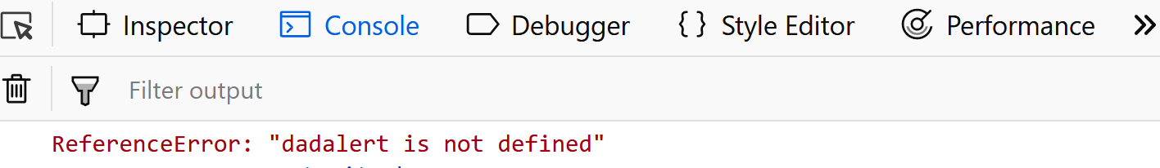

function geekFunc() {

let a = 10;

try {

console.log("Value of variable a is : " + a);

}

catch (e) {

console.log("Error: " + e.description);

}

}

geekFunc();

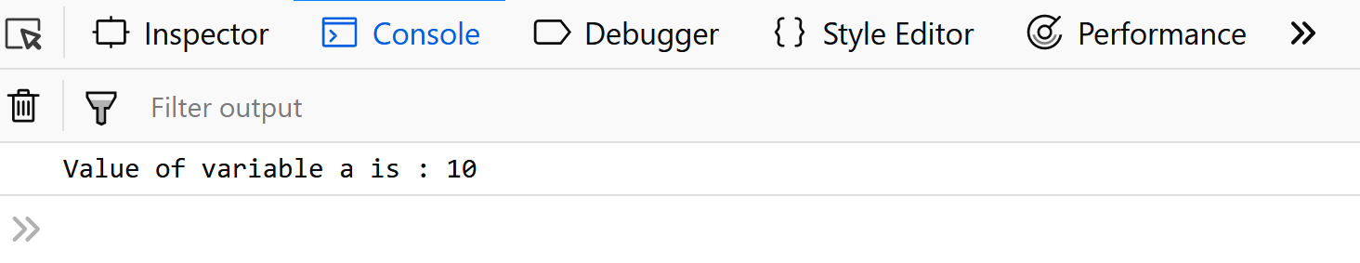

try {

throw new Error('Yeah... Sorry');

}

catch (e) {

console.log(e);

}

# Arrow functions in JavaScript

## What is Arrow Function ?

**Arrow function {()=>}**is concise way of writing JavaScript functions in shorter way. **Arrow functions** were introduced in the ES6 version. They make our code more structured and readable.

**Arrow functions** are anonymous functions i.e. functions without a name but they are often assigned to any variable. They are also called **Lambda Functions**.

**Syntax:**

const gfg = () => {  
 console.log( "Hi Geek!" );  
}

const gfg = () => {

console.log( "Hi from GeekforGeeks!" );

}

gfg();

**Output**

Hi from GeekforGeeks!

**Advantages of Arrow Functions**

* Arrow functions reduce the size of the code.
* The return statement and function brackets are optional for single-line functions.
* It increases the readability of the code.
* Arrow functions provide a lexical this binding. It means, they inherit the value of “this” from the enclosing scope. This feature can be advantageous when dealing with event listeners or callback functions where the value of “this” can be uncertain.

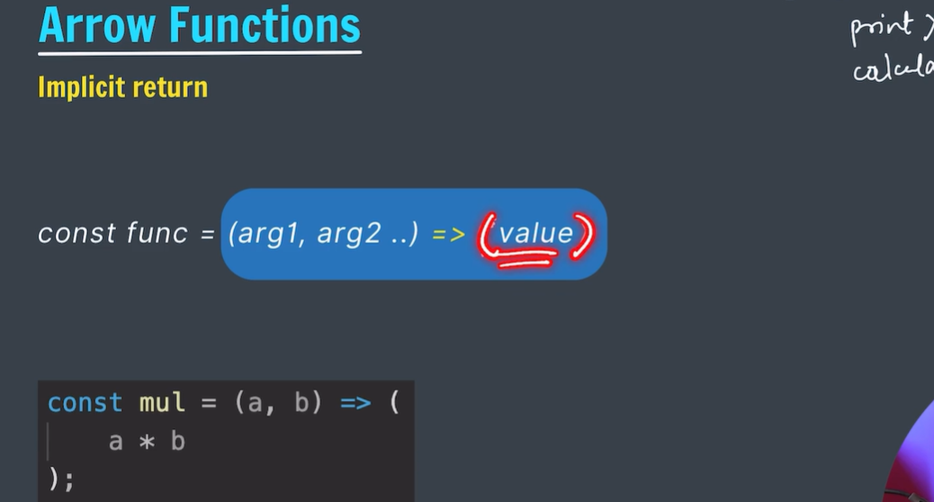

# setTimeout()

In JavaScript, the setTimeout() function is utilized to introduce a delay or to execute a particular function after a specified amount of time has passed. It is part of the Web APIs provided by browsers and Node.js, allowing asynchronous execution of code.

### Syntax:

setTimeout(function, milliseconds, arg1, arg2, ...);

console.log("Start");

setTimeout(function() {

console.log("Delayed log after 2000 milliseconds");

}, 2000);

console.log("End");

**Output:**

Start  
End  
Delayed log after 2000 milliseconds

### **Use Cases:**

1. **Delaying Execution:** It can be used to introduce delays in code execution, useful for scenarios like animations, timed events, or deferred operations.
2. **Asynchronous Operations:** When combined with callback functions, it facilitates asynchronous behavior, enabling non-blocking code execution.
3. **Timeouts in Web Development:** It’s commonly employed in web development for handling timeouts, such as showing a notification after a certain time or refreshing content.

const myTimeout = setTimeout(myGreeting, 3000);  
  
function myGreeting() {  
  document.getElementById("demo").innerHTML = "Happy Birthday to You !!"  
}  
  
function myStopFunction() {  
  clearTimeout(myTimeout);  
}

# JavaScript setInterval() Method

JavaScript **setInterval()** method is used to repeatedly execute a given function at specified intervals.

The **setInterval() method** continues calling the function until **clearInterval()** is called or the window is closed.

**Important Note:**

* **setTimeout()** is for executing a function once after a specified delay.
* **setInterval()** is for executing a function repeatedly at specified intervals until explicitly cleared.

### Syntax:

setInterval(function, delay);

* **function:** The function to be executed at each interval.
* **delay:** The time, in milliseconds, between each execution of the function.

function myFunction() {

console.log("Executing at regular intervals!");

}

// Call myFunction every 1000 milliseconds (1 second)

setInterval(myFunction, 1000);

**Output: (Will be printed after 1 sec or 1000ms)**

Executing at regular intervals!

**Note: Since the setInterval() method executes the function infinitely hence there is a method called as [clearInterval()](https://www.geeksforgeeks.org/javascript-cleartimeout-clearinterval-method/" \t "_blank) to stop the execution of the setInterval().**

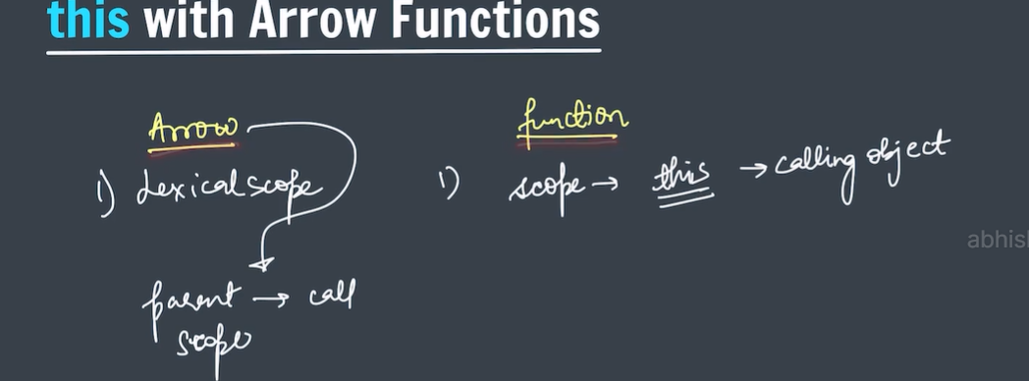

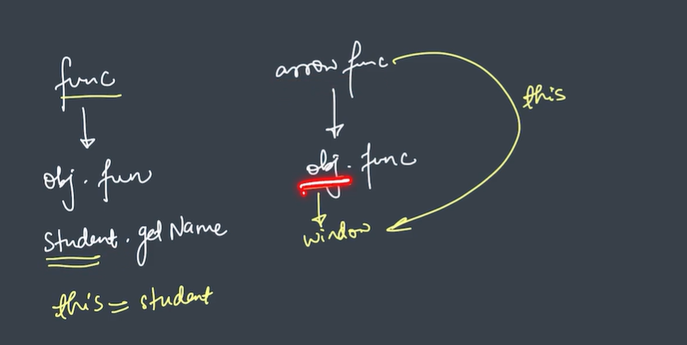

# JavaScript Array Methods

**JavaScript Array**is an object that is used to store a collection of ordered elements under a single variable. Arrays can store elements of different data types and are **resizable**. There are two methods to create arrays-**Array literal** and **Array constructor.**

**Methods in Array:**

# JavaScript Array forEach() Method

The **arr.forEach()** method calls the provided function once for each element of the array. The provided function may perform any kind of operation on the elements of the given array.

### **Syntax:**

array.forEach(callback(element, index, arr), thisValue);

// JavaScript to illustrate forEach() method

function func() {

// Original array

const items = [12, 24, 36];

const copy = [];

items.forEach(function (item) {

copy.push(item + item + 2);

});

console.log(copy);

}

func();

[ 26, 50, 74 ]

## ****JavaScript Array map() Method****

The [map() method](https://www.geeksforgeeks.org/javascript-array-map-method/) creates an array by calling a specific function on each element present in the parent array. It is a non-mutating method. This method iterates over an array and calls the function on every element of an array.

/ Original array

let arr = [4, 9, 16, 25];

// Performing map method

let sub = arr.map(geeks);

function geeks() {

**return** arr.map(Math.sqrt);

}

console.log(sub);

**Output**

[ [ 2, 3, 4, 5 ], [ 2, 3, 4, 5 ], [ 2, 3, 4, 5 ], [ 2, 3, 4, 5 ] ]

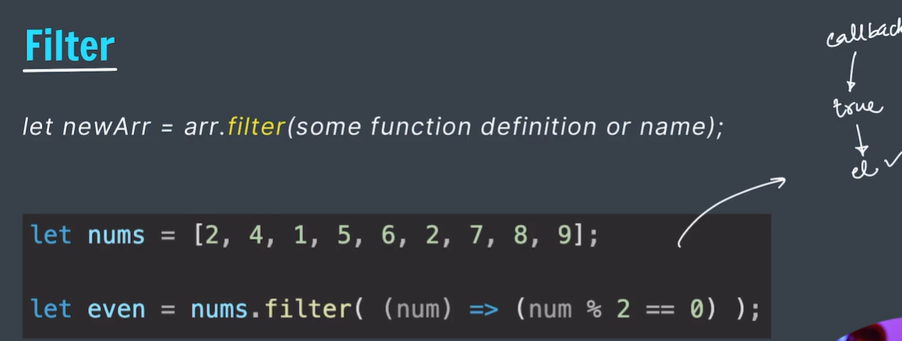

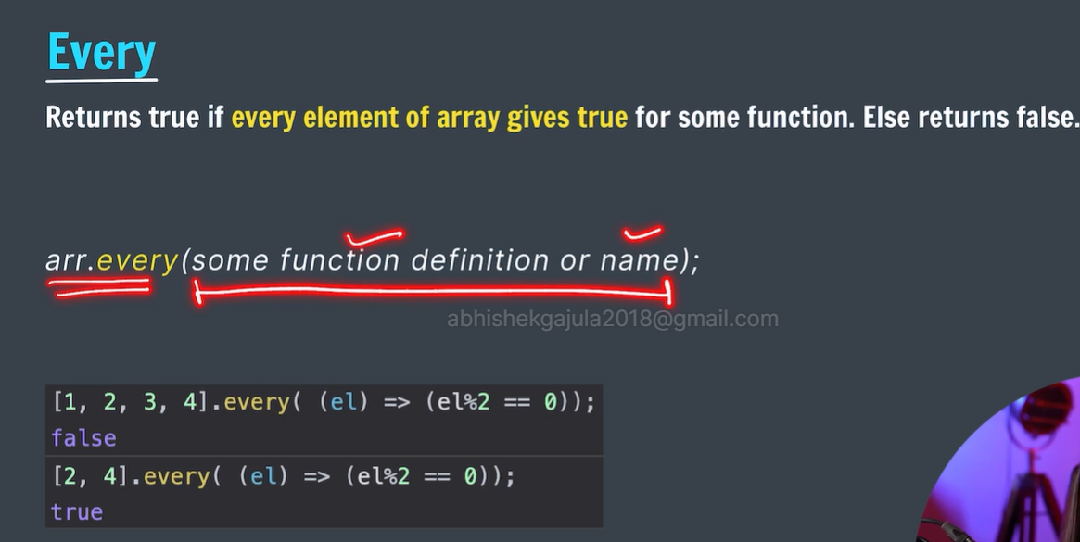

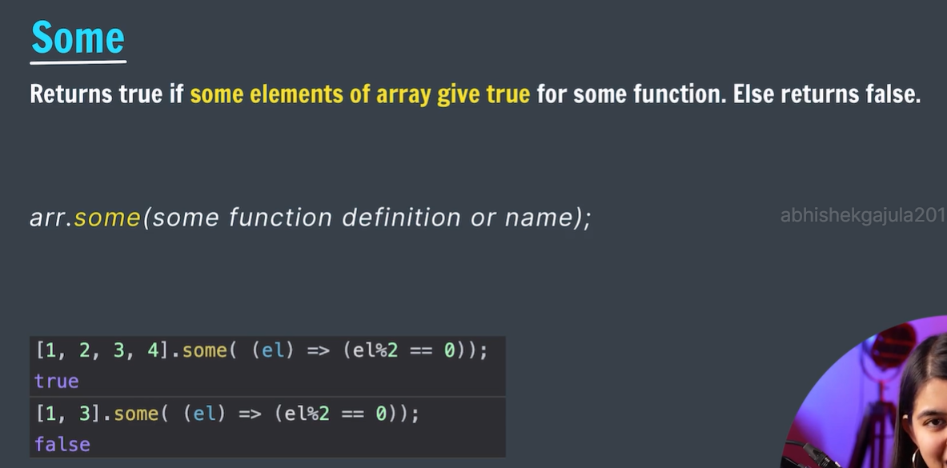

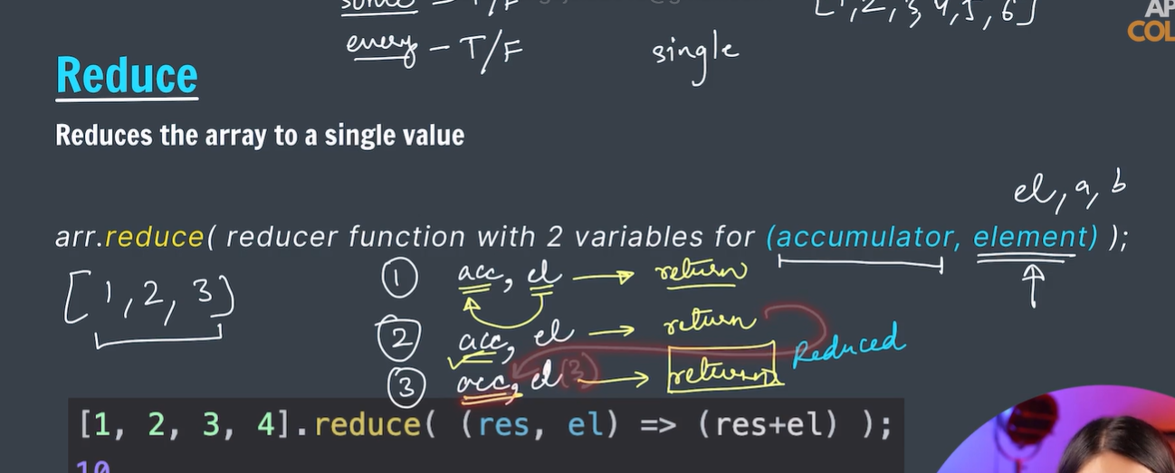

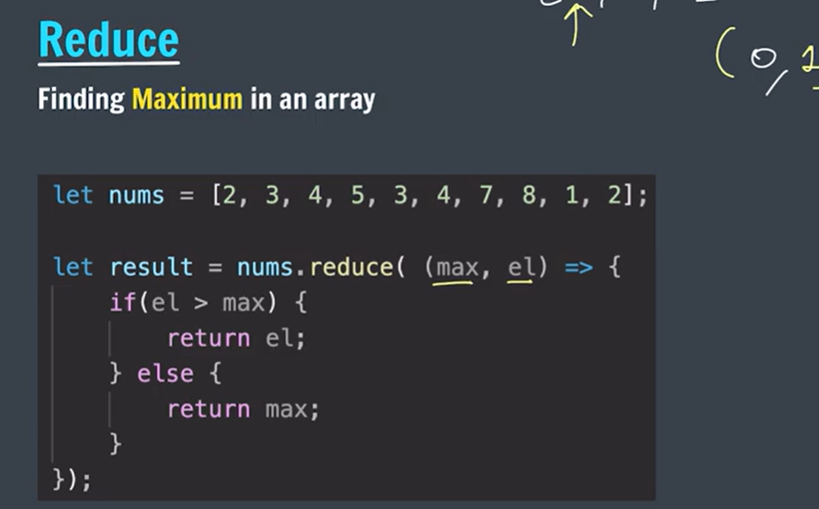

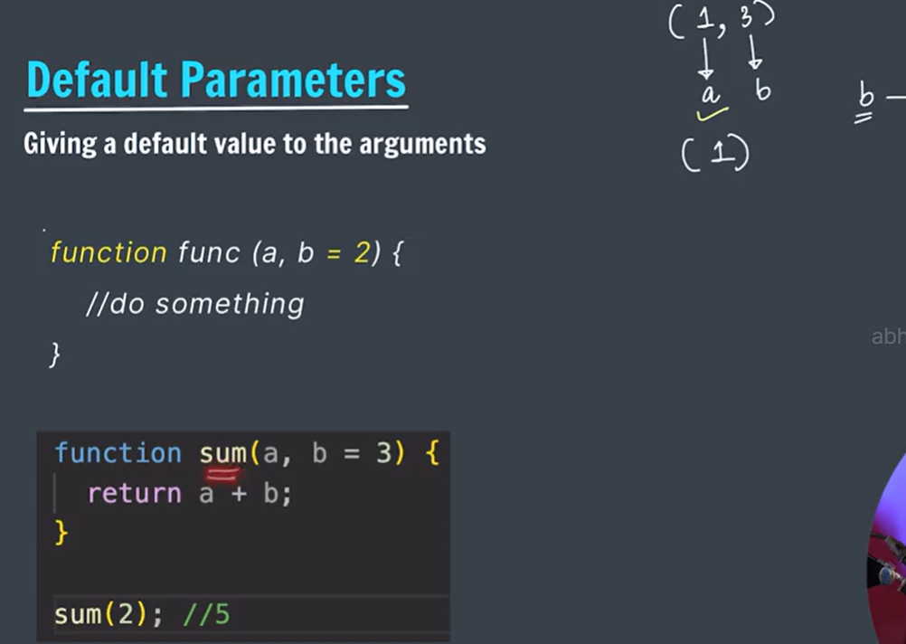

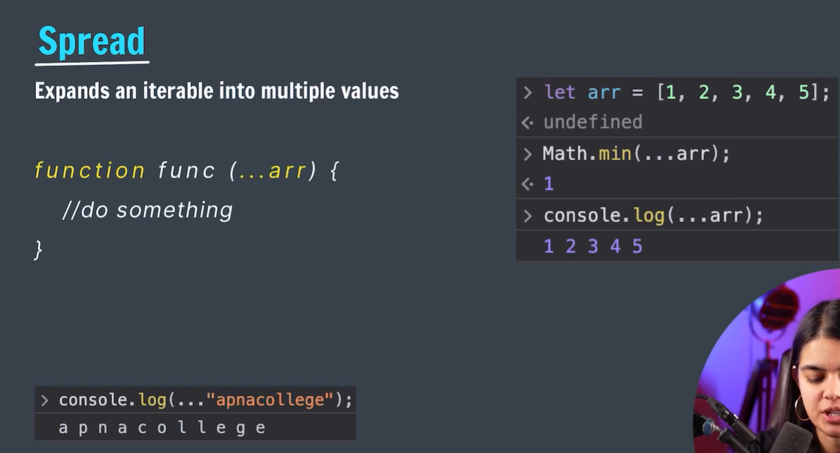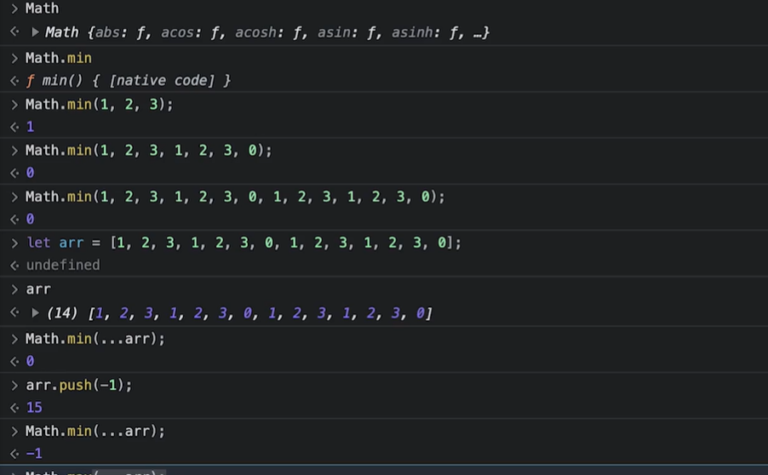

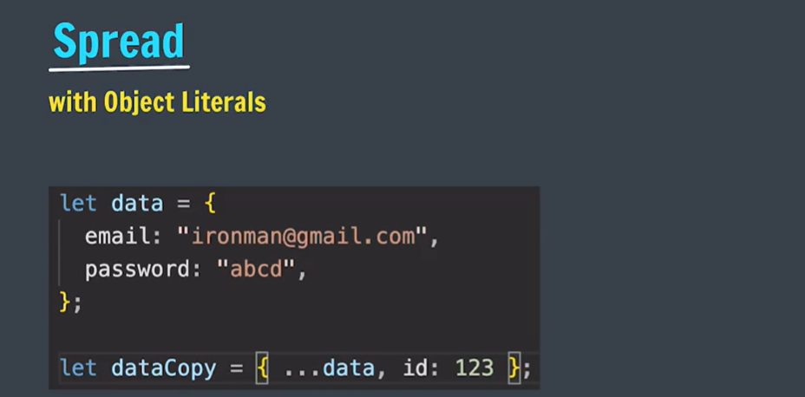

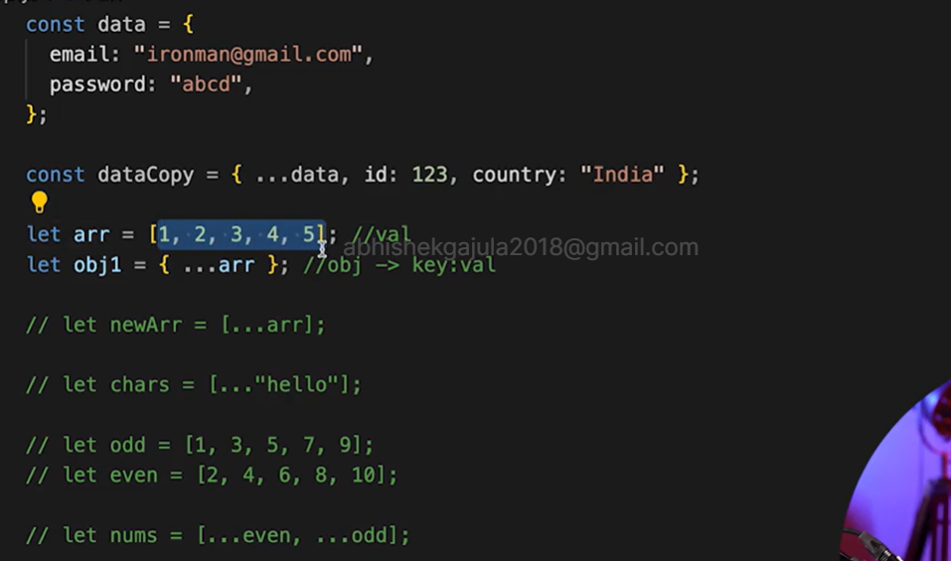

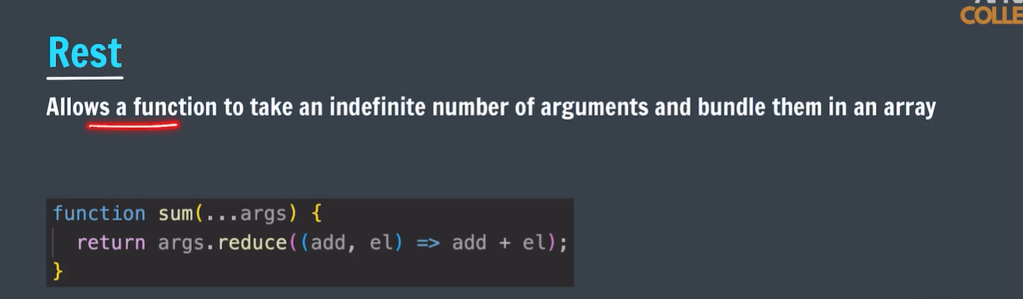

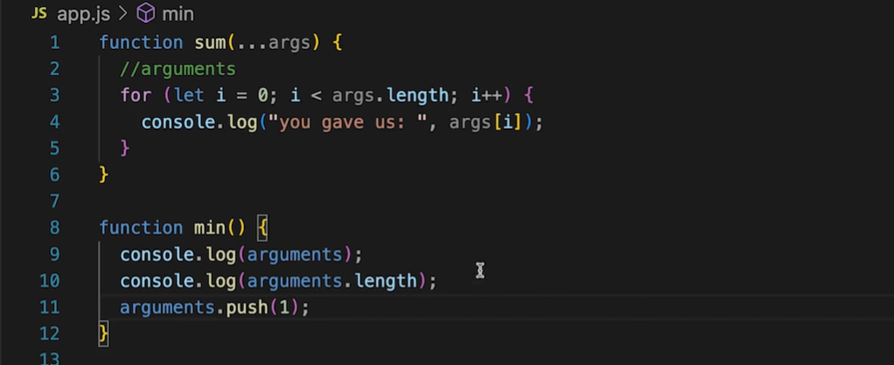

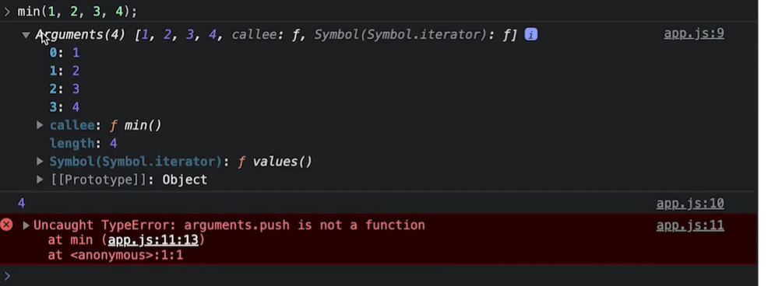

* note: on arguments we can not use array methods directly.

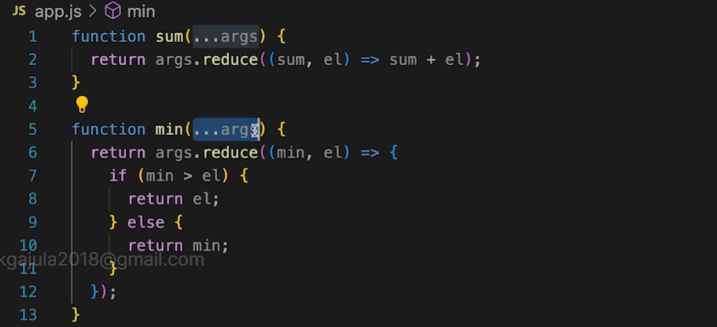

* additional arguments should be mentioned before args.

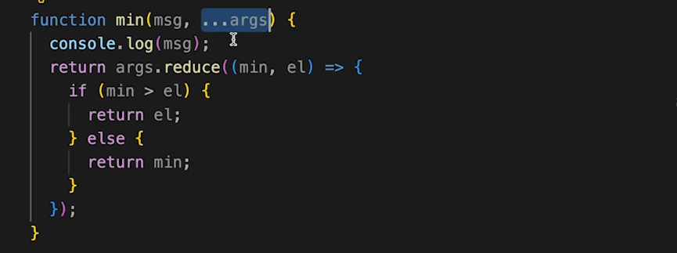

# Different ways to access HTML elements using JavaScript

Sometimes, users need to manipulate the HTML element without changing the code of the HTML. In this scenario, users can use JavaScript to change HTML elements without overwriting them. Before we move ahead to change the HTML element using JavaScript, users should learn to access it from the [DOM](https://www.geeksforgeeks.org/dom-document-object-model/) (Document Object Model). Here, the DOM is the structure of the web page.

## ****Get HTML element by Id****

The user has to add the id to the particular HTML element before accessing the HTML element with the id. Users can use **[getElementById() method](https://www.geeksforgeeks.org/html-dom-getelementbyid-method/" \t "_blank)** to access the HTML element using the id. If any element doesn’t exist with the passed id into the getElementById method, it returns the null value.

document.getElementById(element\_ID);

<!DOCTYPE html>

<html lang="en">

<head>

<title>Document</title>

</head>

<body>

<!-- Heading element with GeeksforGeeks id-->

<h1 id="Geeksforgeeks">

GeeksforGeeks

</h1>

<p>DOM getElementById() Method</p>

<script>

// Accessing the element by getElementById method

let temp = document.getElementById("Geeksforgeeks");

console.log(temp);

console.log(temp.innerHTML);

</script>

</body>

</html>

## [****Get HTML element by className****](https://www.geeksforgeeks.org/html-dom-getelementsbyclassname-method/)

In javascript, the ***getElementsByClassName()*method** is useful to access the HTML elements using the className. The developers can use a single className multiple times in a particular HTML document. When users try to access an element using the className, it returns the collection of all objects that include a particular class.

### **Syntax:**

document.getElementsByClassName(element\_classnames);

### **Parameter:**

It takes the multiple class names of the element which the user wants to access.

### **Return value:**

It returns the collection of objects that have a particular class name. Users can get every element from the collection object using the index that starts from 0.

<!DOCTYPE html>

<html lang="en">

<head>

<title>Document</title>

</head>

<body>

<!-- Multiple html element with GeeksforGeeks class name -->

<h1 class="GeeksforGeeks">GeeksforGeeks sample 1</h1>

<h1 class="GeeksforGeeks">GeeksforGeeks sample 2</h1>

<h1 class="GeeksforGeeks">GeeksforGeeks sample 3</h1>

<p>DOM getElementsByclassName() Method</p>

<script>

// Accessing the element by getElementsByclassName method

let temp = document.getElementsByClassName("GeeksforGeeks");

console.log(temp[0]);

console.log(temp[1]);

console.log(temp[2]);

</script>

</body>

</html>

## [****Get HTML elements by TagName****](https://www.geeksforgeeks.org/html-dom-getelementsbytagname-method/)

### **Syntax:**

document.getElementsByTagName(Tag\_name);

### **Parameter:**

It takes a single parameter which is the tag name.

### **Return value:**

It returns the collection of elements that includes the tag which passed as a parameter.

<!DOCTYPE html>

<html lang="en">

<head>

<title>Document</title>

</head>

<body>

<!-- Multiple html element with h1 tag -->

<h1>GeeksforGeeks sample 1</h1>

<h1>GeeksforGeeks sample 2</h1>

<h1>GeeksforGeeks sample 3</h1>

<p>DOM getElementsByTagName() Method</p>

<script>

// Accessing the element by

// getElementsByTagName method

let temp = document.getElementsByTagName("h1");

console.log(temp[0]);

console.log(temp[1]);

console.log(temp[2]);

</script>

</body>

</html>

9347897327

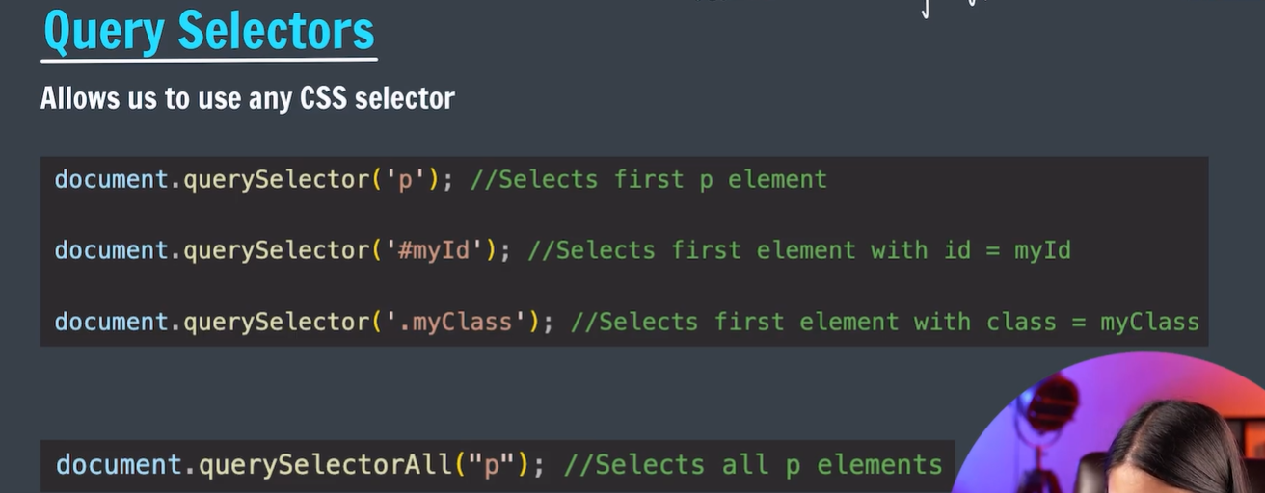

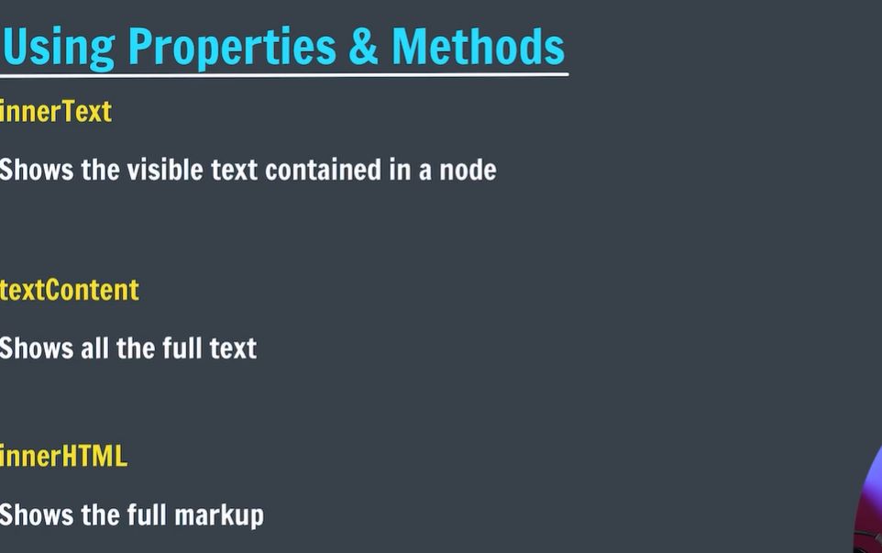

* INNERHTML: it will show the whole html code of the given element.
* Textcontent: it will show the whole content which is taken directly from the html document.
* innerText: it will show the text which is visible on the screen
* 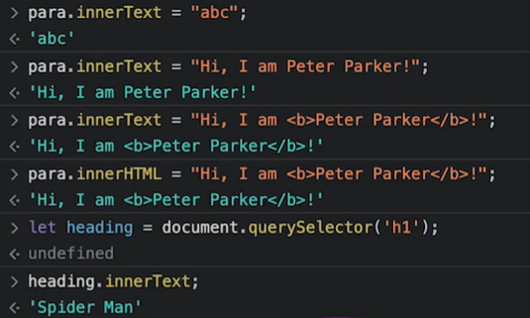

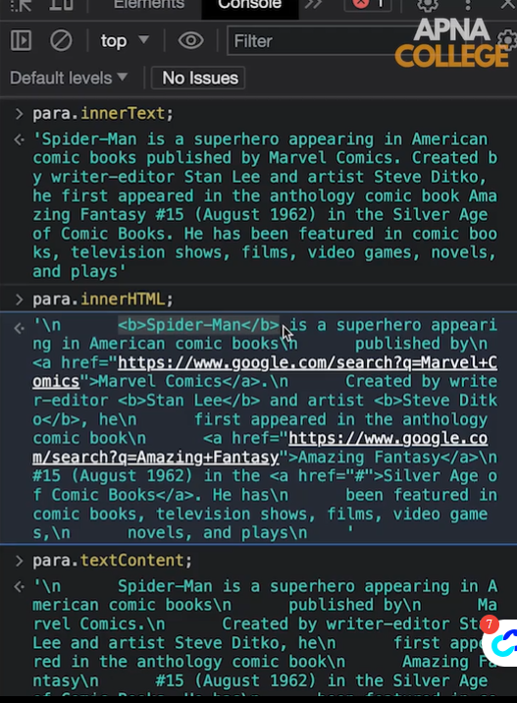

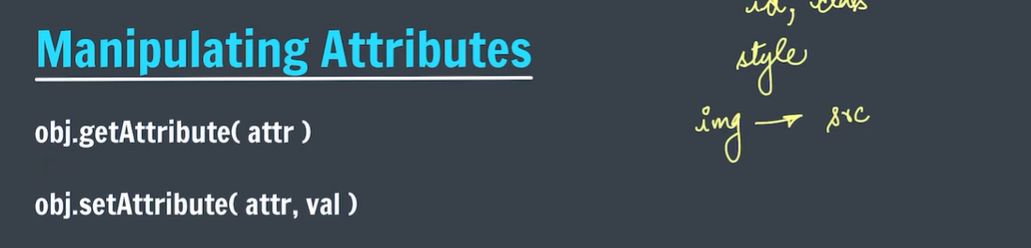

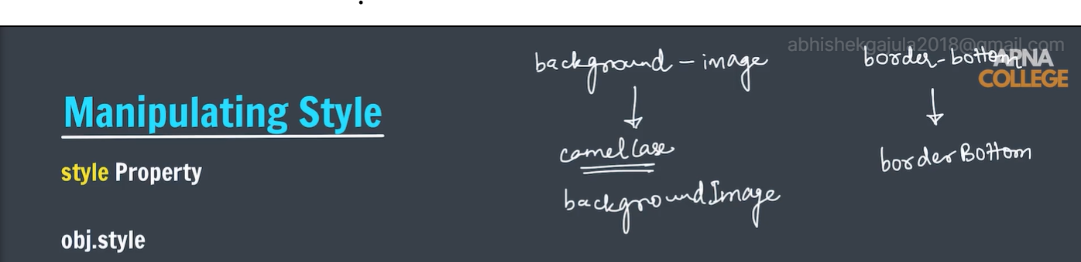

* All css properties follow the camel case instead of hyphens between the properties.
* 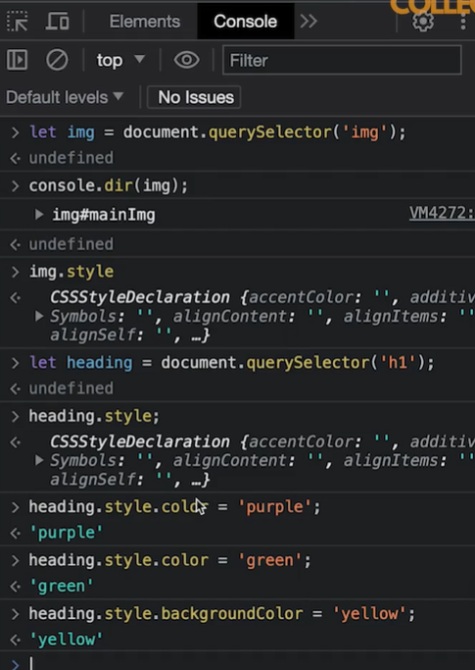

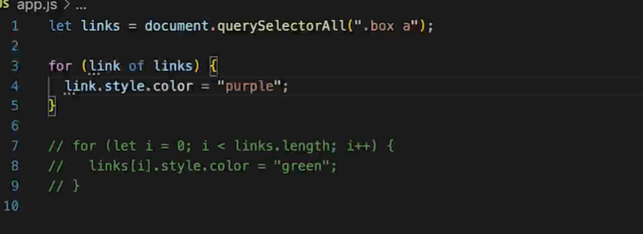

* Using the above style tag we can able to use inline styles only.

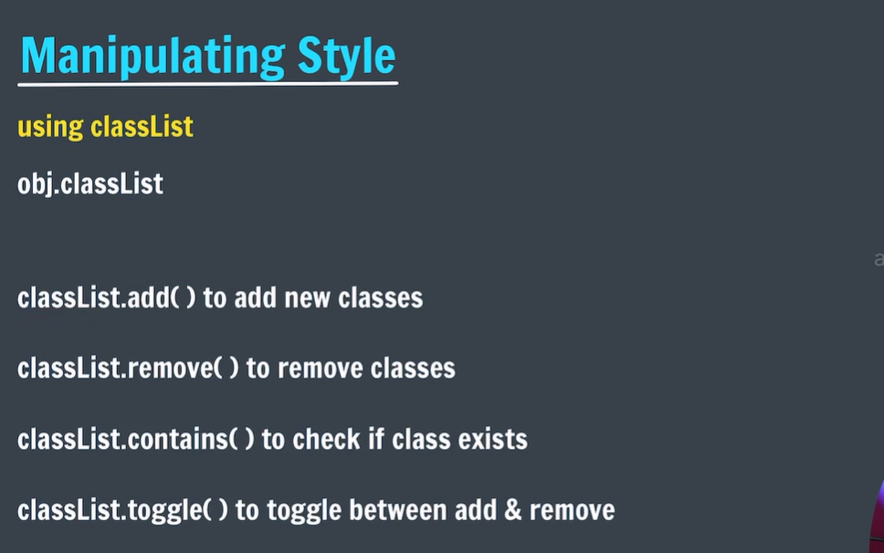

* Ex:

//create class in css file

.green{

Background-color:green;

}

//and add that class

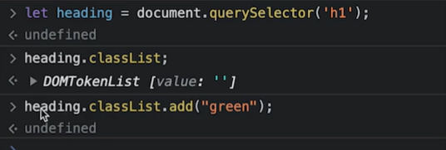

* Note:set attribute allows only one class at a time.
* 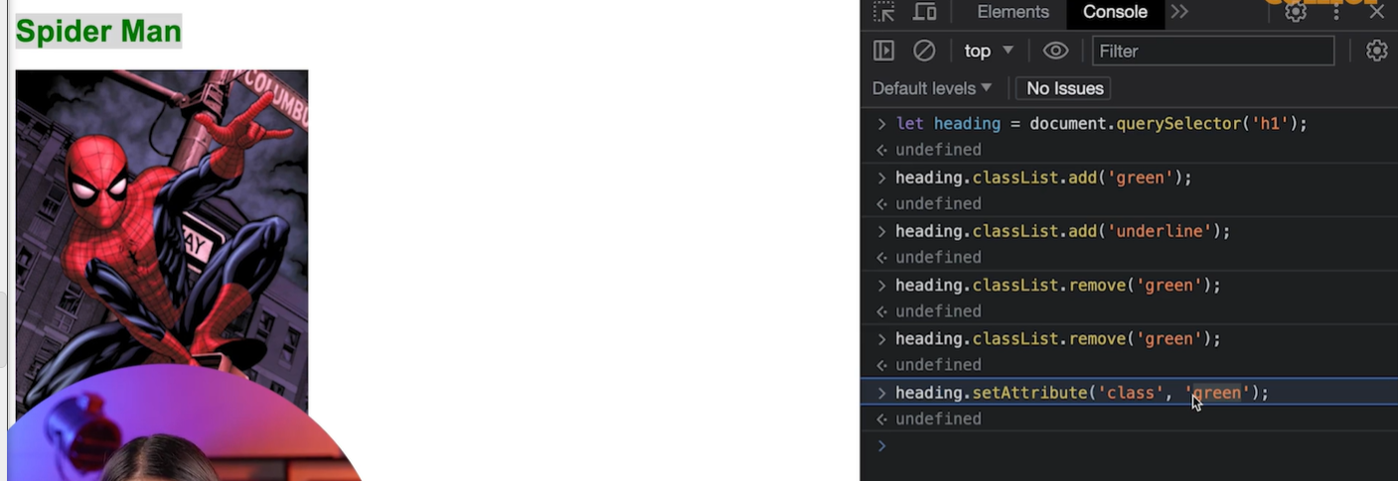heading.classList.contains(“green”);

returns true.

* Heading.classList.contains(“green”);

If green class exists it will remove and if not exists it will add.

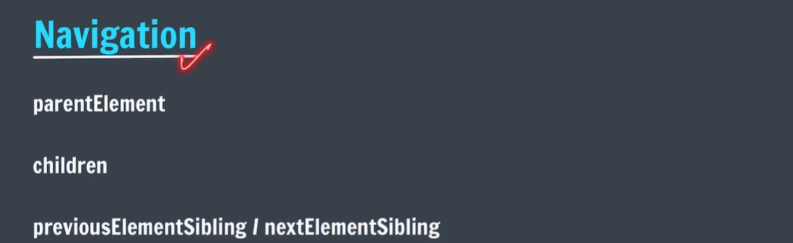

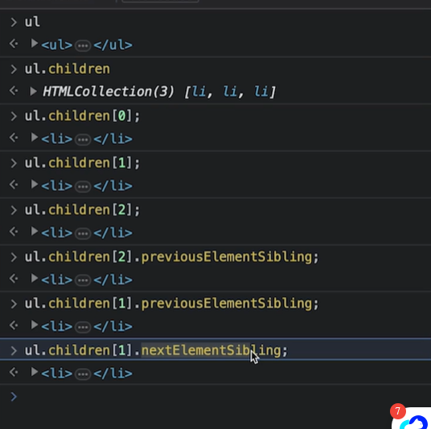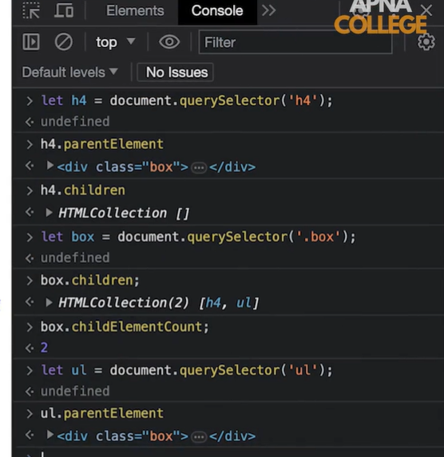

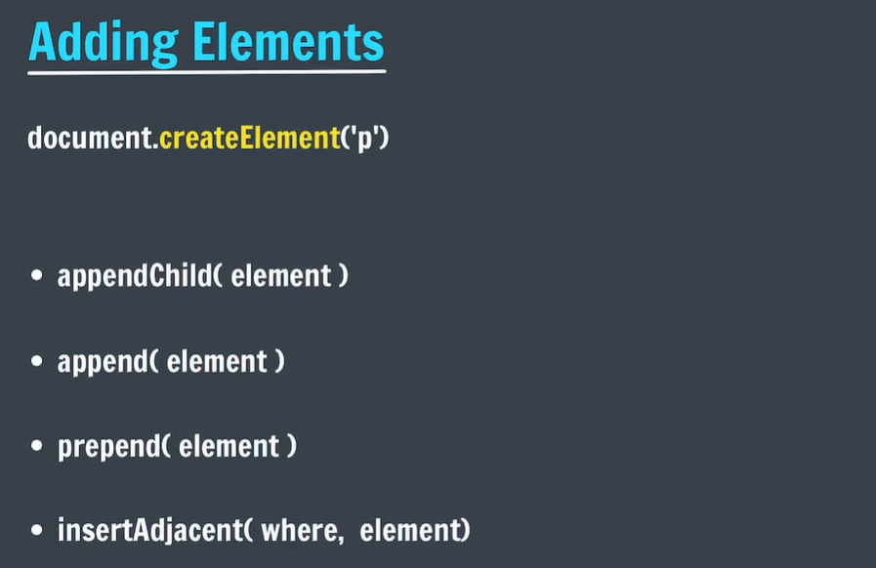

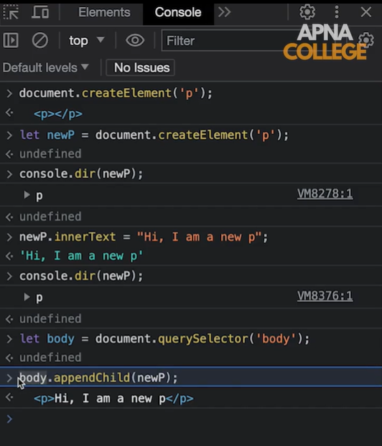

* Appendchild will add it to end of the given parent element.

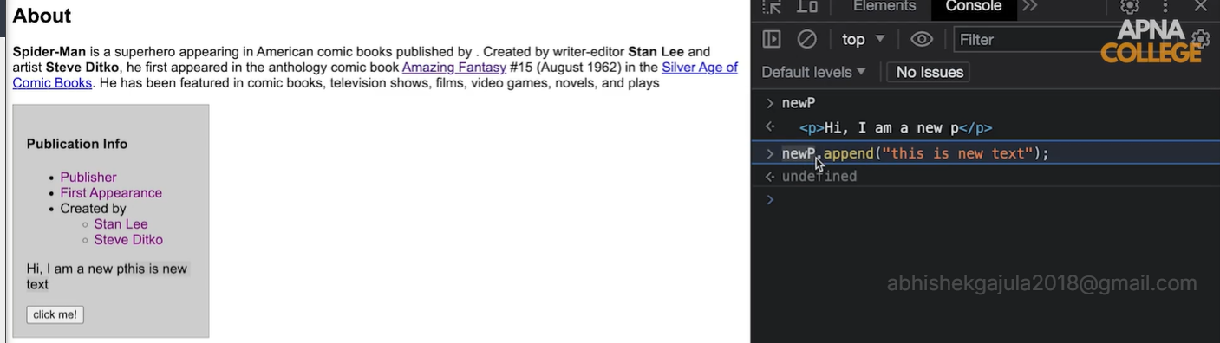

* Prepend will add the elements at the starting position.

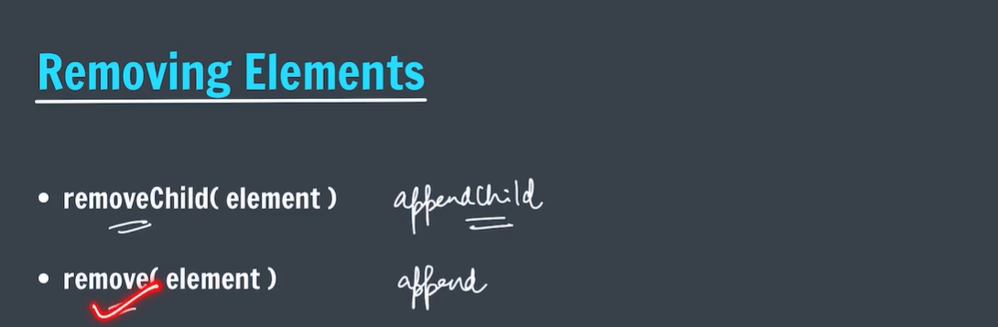

# Dom events:

# How to use DOM and Events ?

[**DOM**(**Document Object Model**)](https://www.geeksforgeeks.org/dom-document-object-model/), a programming interface that is used to connect web pages to scripts by representing the structure of a document such as [HTML](https://www.geeksforgeeks.org/html-tutorials/)documents. It defines the way a document is to be accessed and manipulated and also defines the logical structure of documents.

The way DOM represents a document is with a logic tree ( **DOM Tree** ). To provide a dynamic interface to a webpage, we use [**events** in JavaScript](https://www.geeksforgeeks.org/javascript-events/) . These events are attached to elements in the **DOM**( **Document Object Model** ).

* **Mouse Events:**These are the most common events with basic interaction of user through the mouse.
  + [**onclick**](https://www.geeksforgeeks.org/html-dom-onclick-event/)**:** It fires when a mouse click is triggered on an element.
  + [**onmouseover**](https://www.geeksforgeeks.org/html-onmouseover-event-attribute/)**:** It fires when a mouse pointer moves over an element.
  + [**ondblclick**](https://www.geeksforgeeks.org/html-ondblclick-event-attribute/)**:** It fires on a mouse double click on the element

# HTML DOM onclick Event

The **HTML DOM onclick event** occurs when the user clicks on an element.

There are three ways to add **onclick events**:

<element onclick="myScript">

**In JavaScript:**

object.onclick = function(){myScript};

**In JavaScript, using the addEventListener() Method:**

object.addEventListener("click", myScript);

<center>

<h2>HTML DOM onclick Event in Html</h2>

<button onclick="myFunction()">Click me</button>

<p id="gfg"></p>

<script>

function myFunction() {

document.getElementById(

"gfg").innerHTML = "GeeksforGeeks";

}

</script>

</center>

**Example 3:** In JavaScript, using the addEventListener() method:

<center>

<h2>HTML DOM onclick Event</h2>

<p id="gfg">Click me.</p>

<script>

document.getElementById(

"gfg").addEventListener("click", GFGfun);

function GFGfun() {

document.getElementById(

"gfg").innerHTML = "YOU CLICKED ME!";

document.getElementById(

"gfg").style.color = 'red';

document.getElementById(

"gfg").style.background = 'cyan';

}

</script>

</center>

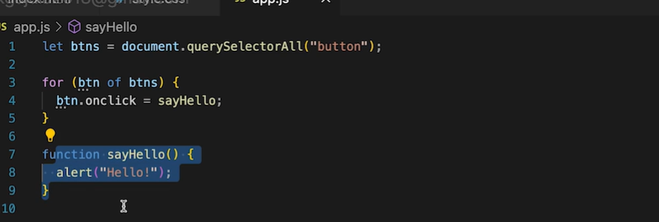

* To select multiple buttons

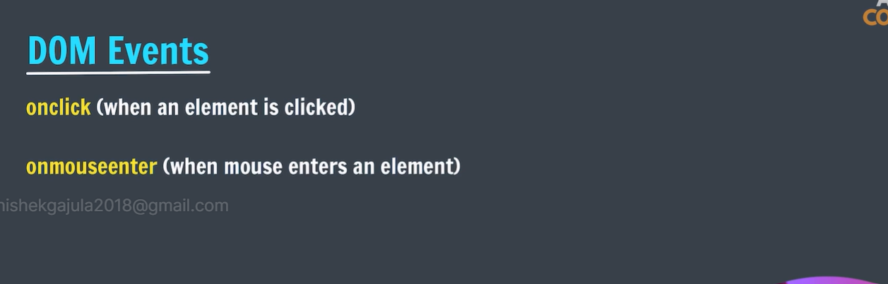

# HTML onmouseover Event Attribute

**The onmouseover event** attribute works when the mouse pointer moves over the specified element. It is basically:

* Activated when the mouse pointer enters the designated [HTML](https://www.geeksforgeeks.org/html-introduction/) element.
* Enables executing JavaScript code when the mouse hovers over the element.
* Ideal for enhancing user experience by providing feedback or additional information.

## ****Syntax****

<element onmouseover = "script">

* Using onclick we can only define only one function at a time.
* Using event listener we specify multiple events on single element.

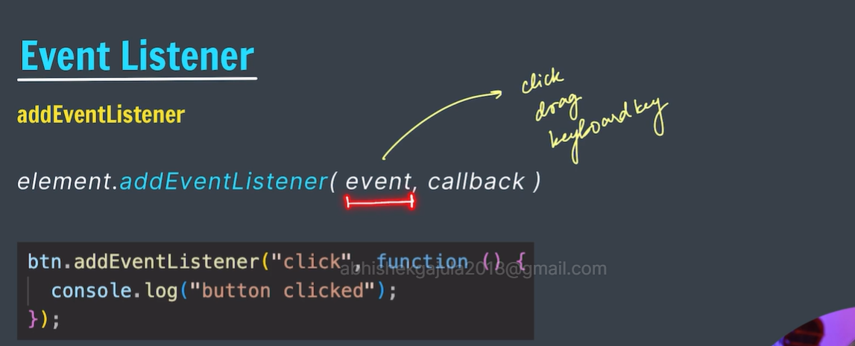

* To generate random colors:

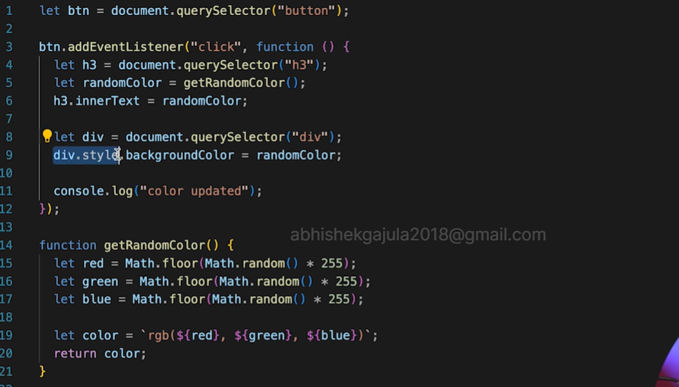

* Note : we can also use mouse events on different elements:
* **This refers to object that is responsible for action event.**

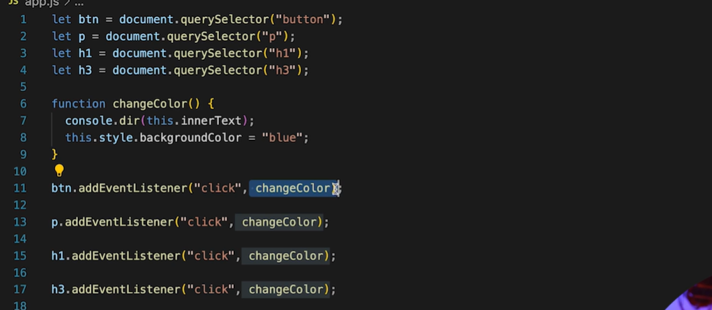

* “event” default argument to the call back function.
* From which we can acquire the information about the object that is generated the event. 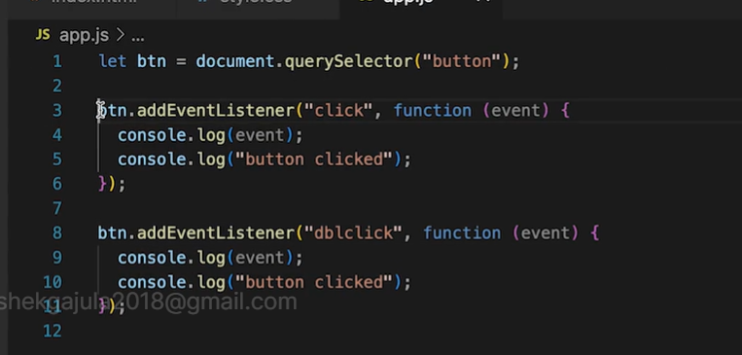

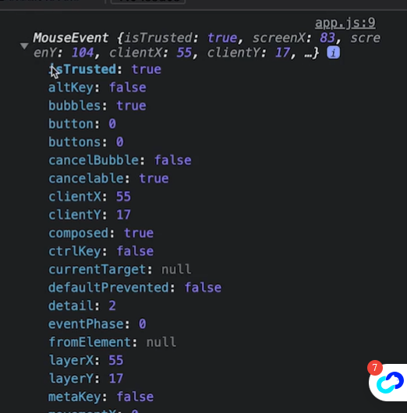

## Keyboard Events

The KeyboardEvent Object handles events that occur when a user presses a key on the keyboard.

|  |  |
| --- | --- |
| **Event** | **Occurs When** |
| [onkeydown](https://www.w3schools.com/jsref/event_onkeydown.asp) | A user presses a key |
| [onkeypress](https://www.w3schools.com/jsref/event_onkeypress.asp) | A user presses a key |
| [onkeyup](https://www.w3schools.com/jsref/event_onkeyup.asp) | A user releases a key |

* In Html

**<input** type = "text" id = "input\_class" onkeydown = "keyDownFunction()"**>**

In Javascript

**<script>**

var demoObj = document.getElementById("input\_class");

demoObj.onkeydown = keyDownFunction;

**</script>**

In addEventListener event

**<script>**

var demoObj = document.getElementById("input\_class");

demoObj.addEventListener("keydown", keyDownFunction);

**</script>**

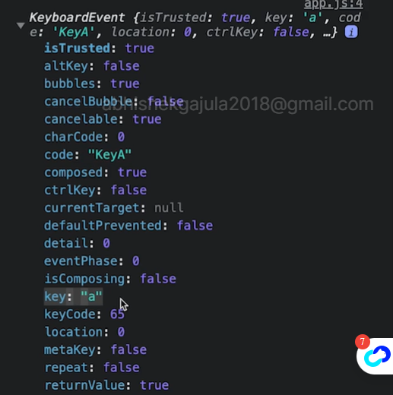

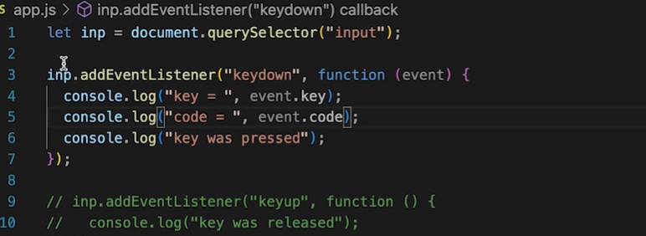

## Form Events

The form events in JavaScript are events that are associated with HTML forms. These events are triggered by user actions when interacting with form elements like text fields, buttons, checkboxes, etc. Form events allow you to execute JavaScript code in response to these actions, enabling you to validate form data, perform actions on form submission or reset, and enhance the user experience.

### **List of Common Form Events**

Here are some common form events:

|  |  |
| --- | --- |
| **Form Event** | **Description** |
| onsubmit | Triggered when a form is submitted. It's often used for form validation before data is sent to the server. |
| onreset | Triggered when the form is reset, allowing you to perform actions when the user resets the form. |
| onchange | Triggered when the value of a form element (input, select, textarea) changes. Commonly used for user input validation or dynamic updates. |
| oninput | Triggered immediately when the value of an input element changes, allowing for real-time handling of user input. |
| onfocus | Triggered when an element receives focus, such as when a user clicks or tabs into an input field. Useful for providing feedback or enhancing the user experience. |
| onblur | Triggered when an element loses focus, such as when a user clicks outside an input field or tabs away. Useful for validation or updates triggered by loss of focus. |

* Note: event.preventDefault() will stops the default behaviour of the element.
* To extract the data from the input element from the form we should use obj.value .

Extracting data from the form:

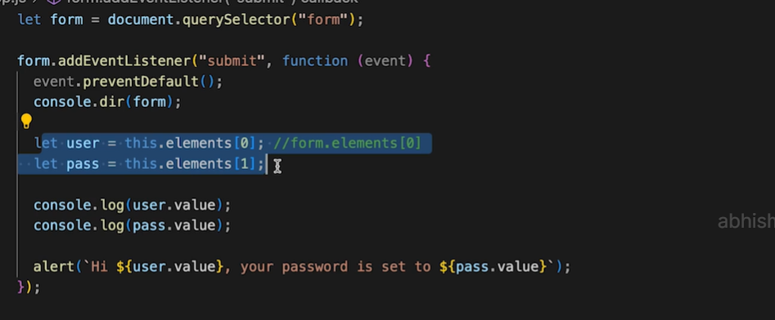

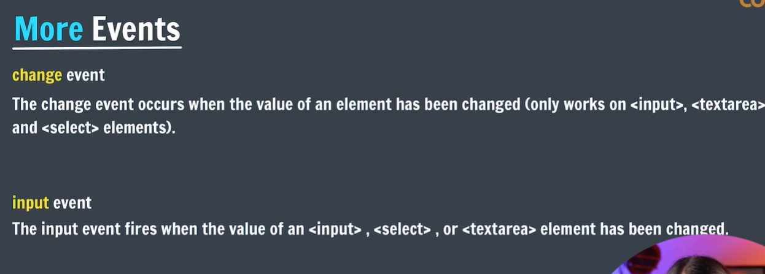> change event: it will be fired when there is a change in the value of the given element between two states (from element active state to diactive state).

> input event: it will be fired when there is a change in the value of the given input element in complete active state.

# Event bubbling:

If there are nested elements then if the internal element generates the event then it also provoke to generate the event from the parent class.

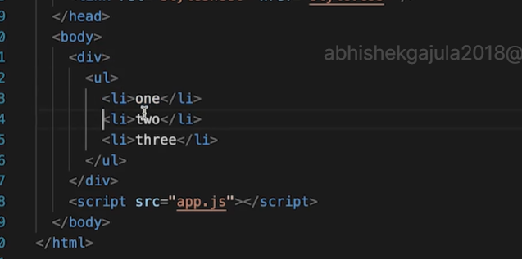

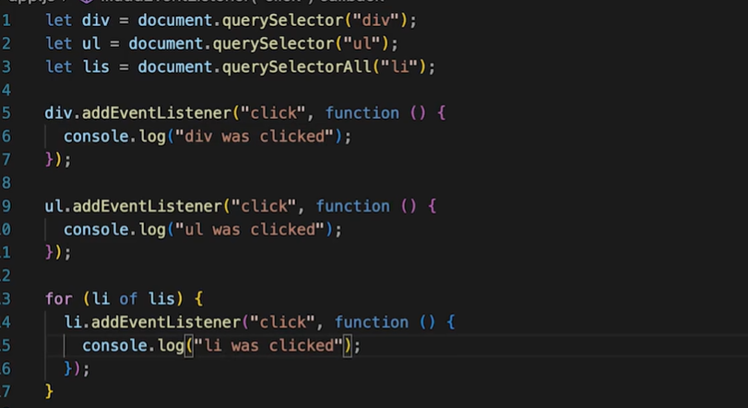

* If we click the inner element lis then all other outer elements will also generate click events.

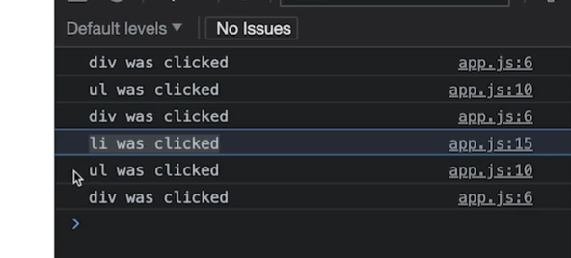

> to stop the above scenario we can use sropPropagation() .

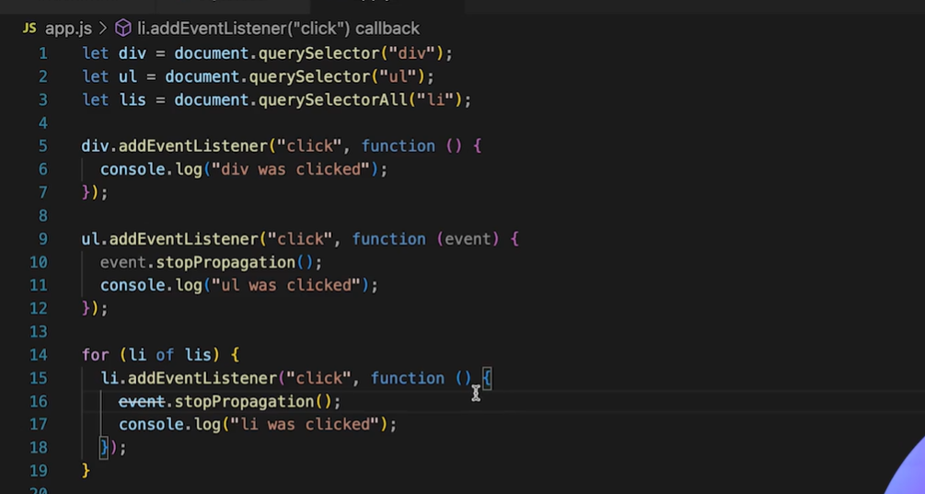

* There is a problem is that if add new button later the event listeners would not add to that new buttons .
* To overcome above problem we should add event listener to the parent class using delegations event model so that the all child elements well get event listeners.

# To visualize the call stack:

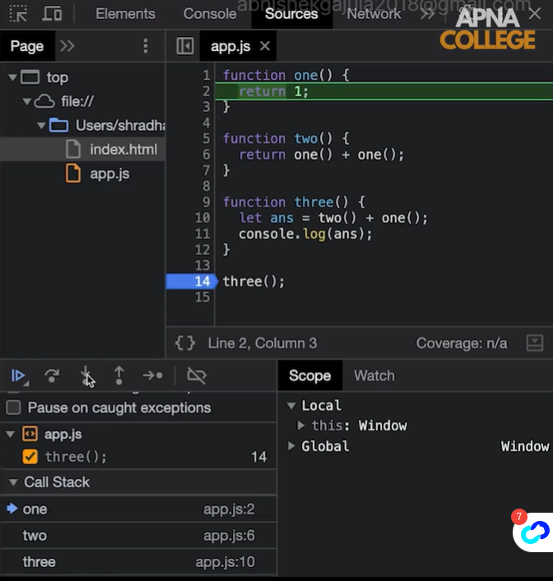

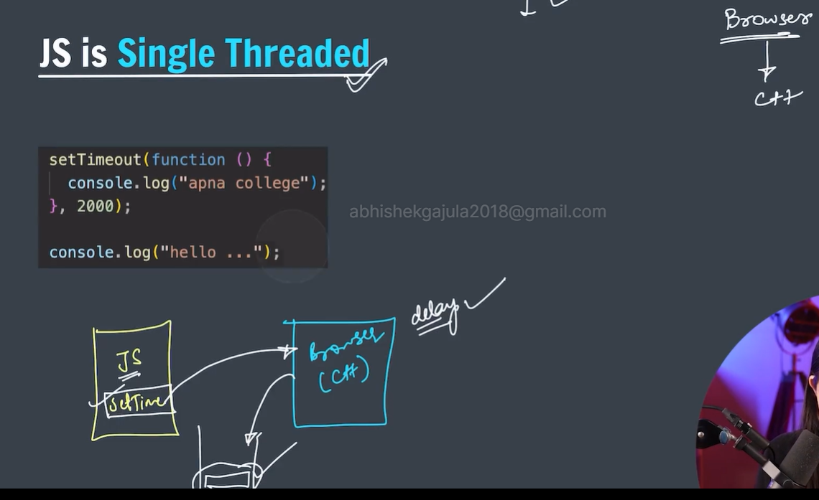

* Js is single threaded model in which all tasks will execute in on single threaded model.
* But when we use settimeout function we are seeing that multiple things executing simultaneously.(this asynchronous feature of javascript)
* This happens becoz of browser takes the responsibility of waiting.
* After the timeout function will be added in call stack.
* Browser is written in cpp so it is multithreaded model.

# Nesting the callbacks leads to callback hell.

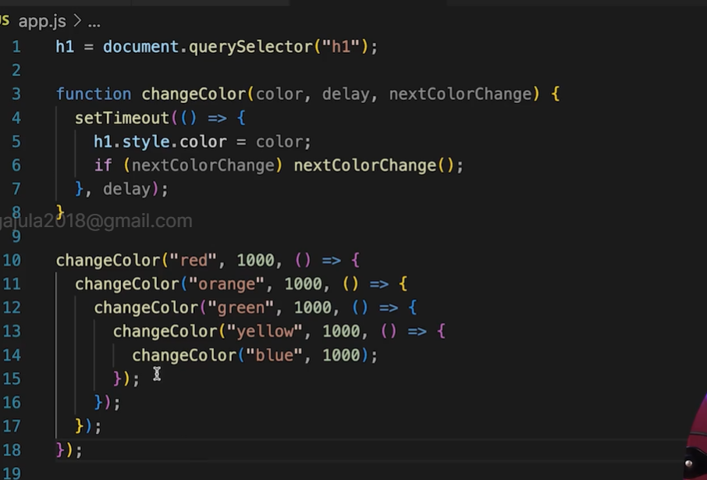

# JavaScript Promise

**JavaScript Promises** to simplify managing multiple asynchronous operations, preventing callback hell and unmanageable code. They represent future values, associating handlers with eventual success or failure, resembling synchronous methods by postponing value delivery until later.

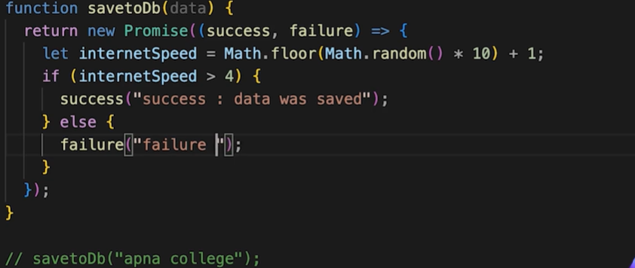

**Syntax:**

let promise = new Promise(function(resolve, reject){  
 //do something  
});

**Parameters**

* The promise constructor takes only one argument which is a callback function
* The callback function takes two arguments, *resolve* and *reject*
  + Perform operations inside the callback function and if everything went well then call resolve.
  + If desired operations do not go well then call reject.

**A Promise has four states:**

1. **fulfilled**: Action related to the promise succeeded
2. **rejected**: Action related to the promise failed
3. **pending**: Promise is still pending i.e. not fulfilled or rejected yet
4. **settled**: Promise has been fulfilled or rejected

let promise = new Promise(function (resolve, reject) {

const x = "geeksforgeeks";

const y = "geeksforgeeks"

if (x === y) {

resolve();

} else {

reject();

}

});

promise.

then(function () {

console.log('Success, You are a GEEK');

}).

catch(function () {

console.log('Some error has occurred');

});

**Promise Consumers:** Promises can be consumed by registering functions using ***.then*** and ***.catch***methods.

### **1. Promise then() Method:**

[Promise method](https://www.geeksforgeeks.org/javascript-promise-then-method/) is invoked when a promise is either resolved or rejected. It may also be defined as a carrier that takes data from promise and further executes it successfully.

**Parameters:** It takes two functions as parameters.

* The first function is executed if the promise is resolved and a result is received.
* The second function is executed if the promise is rejected and an error is received. (It is optional and there is a better way to handle error using .catch() method
* **Syntax:**
* .then(function(result){  
   //handle success  
  }, function(error){  
   //handle error  
  })

let promise = new Promise(function (resolve, reject) {

reject('Promise Rejected')

})

promise

.then(function (successMessage) {

console.log(successMessage);

}, function (errorMessage) {

//error handler function is invoked

console.log(errorMessage);

});

### **2. Promise catch() Method:**

[**Promise catch() Method**](https://www.geeksforgeeks.org/javascript-promise-catch-method/)is invoked when a promise is either rejected or some error has occurred in execution. It is used as an Error Handler whenever at any step there is a chance of getting an error.

**Parameters:** It takes one function as a parameter.

* Function to handle errors or promise rejections.(.catch() method internally calls .then(null, errorHandler), i.e. .catch() is just a shorthand for .then(null, errorHandler) )

**Syntax:**

.catch(function(error){  
 //handle error  
 })

let promise = new Promise(function (resolve, reject) {

reject('Promise Rejected')

})

promise

.then(function (successMessage) {

console.log(successMessage);

})

.catch(function (errorMessage) {

//error handler function is invoked

console.log(errorMessage);

});

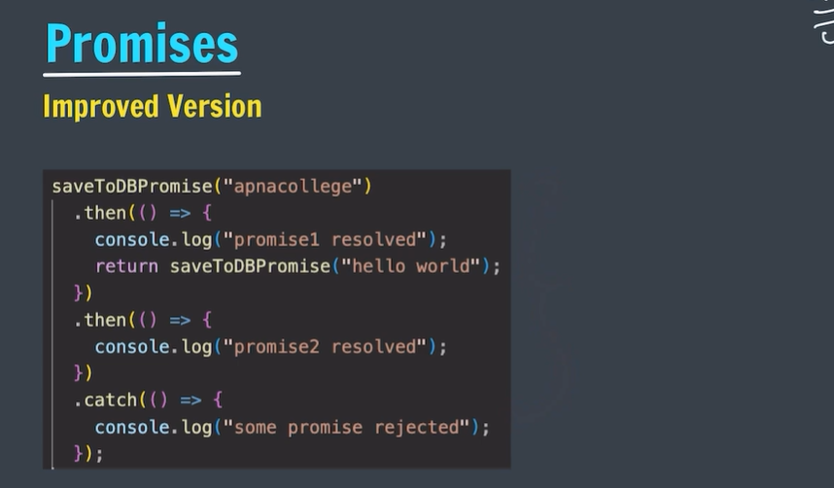

* Second then is method of first then returning object it is also called as chaining.

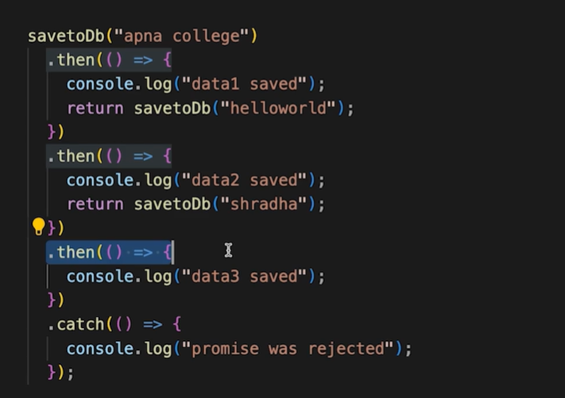

* Grabbing the information or reasons about the result of object that is returned about the promises.

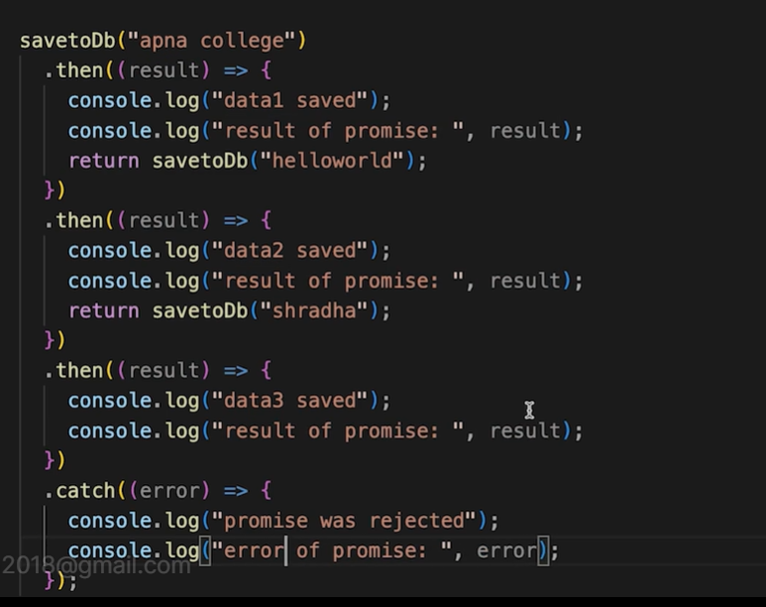

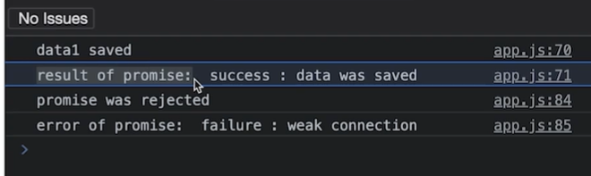

* In the definition of promises we use term that is asynchronous which means functions are dependent on each other or result of other function.

# Async and Await in JavaScript

**Async/await** is a feature in JavaScript that allows you to **work with asynchronous code** in a more synchronous-like manner, making it easier to write and understand asynchronous code.

**Async Functions** always return a promise. **Await Keyword** is used only in Async Functions to wait for promise.

JS Async/Await is the**extension of promises** that we get as support in the language

## Async Function

**The Async function** simply allows us to write **promises-based** code as if it weresynchronous and it checks that we are not breaking the execution thread.

Async functions will always return a value. It makes sure that a promise is returned and if it is not returned then JavaScript automatically wraps it in a promise which is resolved with its value.

### Async Syntax

async function myFunction() {

  return "Hello";

}

**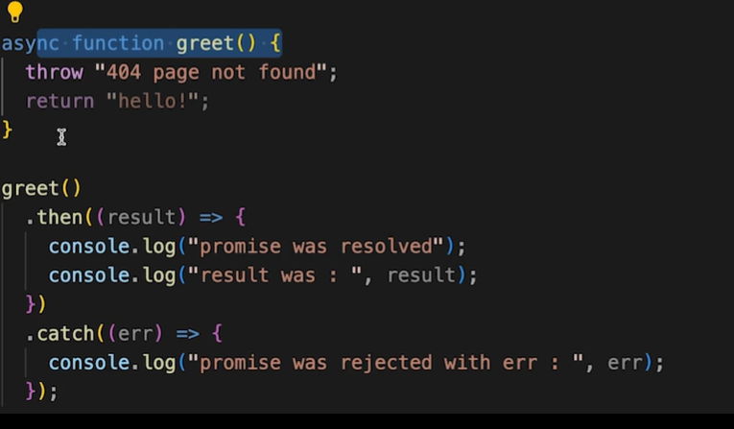**

**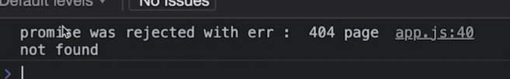**

* **We also create arrow function as async**

## Await Keyword

**Await**is used to wait for the promise. It could be used within the async block only.

It makes the code wait until the promise returns a result.

### Await Syntax

let value = await promise;

**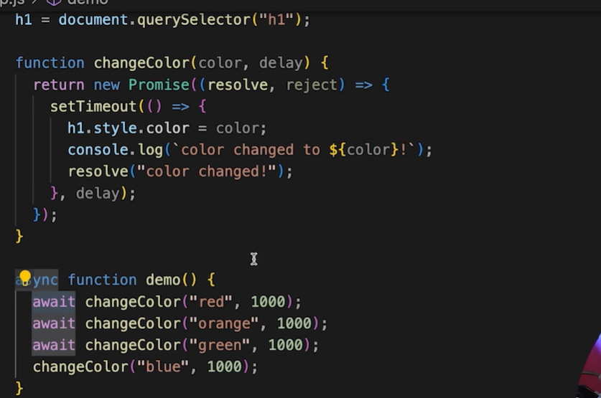**

# Handling the rejections in await:

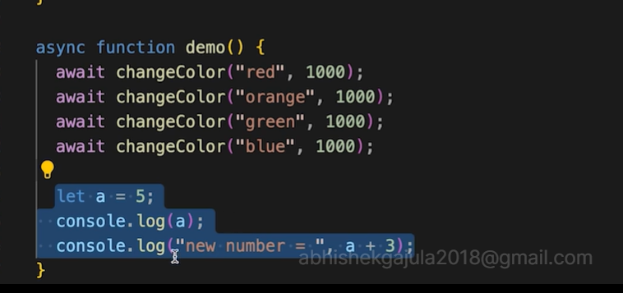

* In the above example if any changeColor block fails it leads to the unsuccessful execution of highlighted code in above example.
* To handle such situation we can use try and catch blocks.

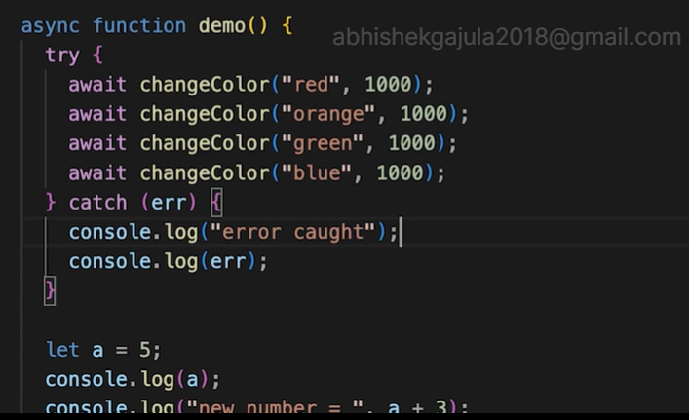

**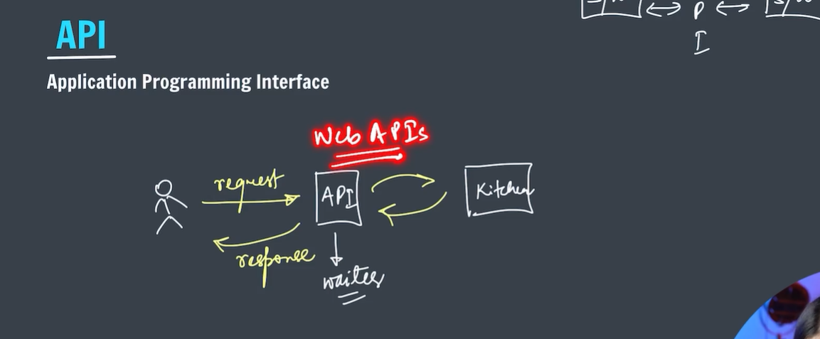**

# What is Web API and why we use it ?

API stands for Application Programming Interface. API is actually some kind of interface which is having a set of functions. These set of functions will allow programmers to acquire some specific features or the data of an application.

Web API is an API as the name suggests, it can be accessed over the web using the HTTP protocol. It is a framework that helps you to create and develop HTTP based RESTFUL services. The web API can be developed by using different technologies such as java, ASP.NET, etc. Web API is used in either a web server or a web browser

Basically Web API is a web development concept. It is limited to Web Application’s client-side and also it does not include a web server or web browser details. If an application is to be used on a distributed system and to provide services on different devices like laptops, mobiles, etc then web API services are used. Web API is the enhanced form of the web application.

**ASP.NET Web API:** ASP.NET stands for Active Server Pages.NET. It is mostly used for creating web pages and web technologies. It is considered a very important tool for developers to build dynamic web pages using languages like C# and Visual Basic. ASP.NET Web API is a framework that helps you to build services by making it easy to reach a wide range of clients including browsers, mobiles, tablets, etc. With the help of ASP.NET, you can use the same framework and same patterns for creating web pages and services both.

**Where to use Web API?**

1. Web APIs are very useful in implementation of RESTFUL web services using .NET framework.
2. Web API helps in enabling the development of HTTP services to reach out to client entities like browser, devices or tablets.
3. ASP.NET Web API can be used with MVC for any type of application.
4. A web API can help you develop ASP.NET application via AJAX.
5. Hence, web API makes it easier for the developers to build an ASP.NET application that is compatible with any browser and almost any device.

**Steps to use Web API:**

* Most APIs require an API key. Once you find an API you want to play with, look in the documentation for access requirements. Most APIs will ask you to complete an identity verification, like signing in with your Google account. You’ll get a unique string of letters and numbers to use when accessing the API.
* The easiest way to start using an API is by finding an HTTP client online, like REST-Client, Postman, or Paw. These ready-made tools help you structure your requests to access existing APIs with the API key you received. You’ll still need to know some of the syntaxes from the documentation, but there is very little coding knowledge required.
* The next best way to pull data from an API is by building a URL from existing API documentation.

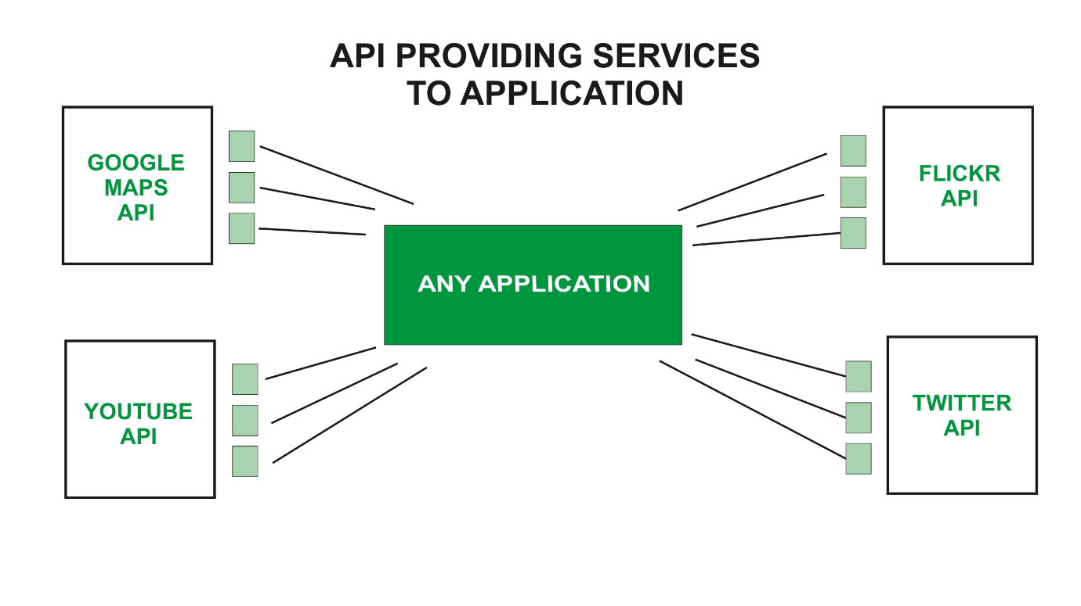

* **The result returned from the API will be in the form of JSON format.**

# JSON

**JSON** stands for **JavaScript Object Notation**. It is a format for structuring data. This format is used by different web applications to communicate with each other. It is the replacement of the **XML** data exchange format. It is easier to structure the data compared to **XML**. It supports data structures like arrays and objects, and **JSON** documents that are rapidly executed on the server.

**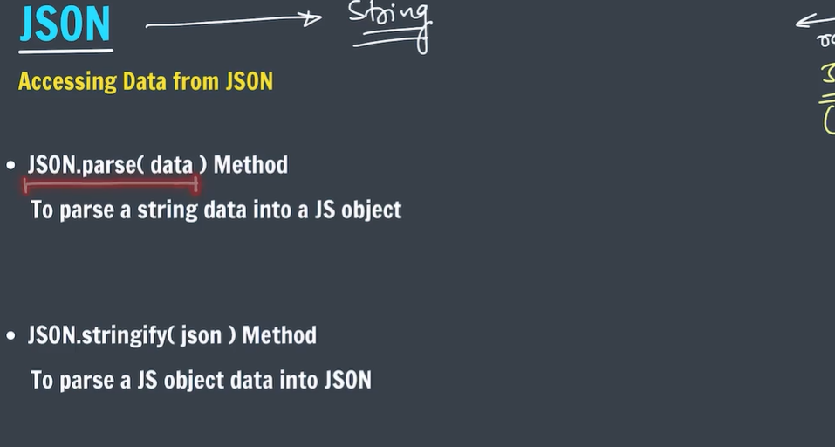**

**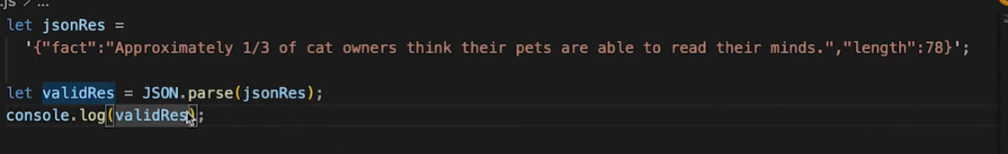**

## What is API testing?

API testing is the process of confirming that an API is working as expected. Developers can run API tests manually, or they can automate them with an API testing tool. There are several types of API tests, and each one plays a distinct role in ensuring the API remains reliable.

**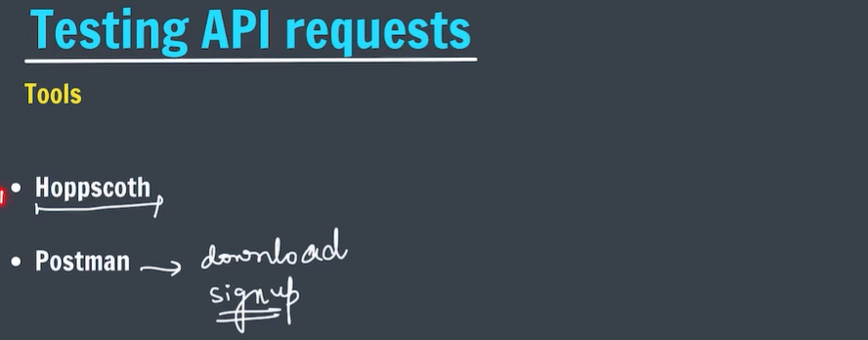**

# Ajax Introduction

 Facebook, Instagram, Twitter etc are considered the situation when check news feed and if like someone post simply click the like button and the like count is added without refreshing the page.

ow imagine the situation if there would be the case, click the like button and the complete page would be loaded again which will make such processes. Now the question whether clicking the button again for such a small task which require complete loading of a web page.

Absolutely not, because no one will do such an absurd thing (in the latter case). So it means that this feature of like is very helpful as it prevents the reloading of the complete page. It communicates only necessary information with the server and shows to the end user(in this case being the increase of like count).

**What is Ajax?**  
Ajax is an acronym for Asynchronous Javascript and XML. It is used to communicate with the server without refreshing the web page and thus increasing the user experience and better performance.

# Different kinds of HTTP requests

**HTTP (Hypertext Transfer Protocol)** specifies a collection of request methods to specify what action is to be performed on a particular resource. The most commonly used HTTP request methods are **GET, POST, PUT, PATCH, and DELETE**. These are equivalent to the **CRUD operations (create, read, update, and delete)**.

**GET:**GET request is used to read/retrieve data from a web server. GET returns an HTTP status code of **200 (OK)** if the data is successfully retrieved from the server.

**POST:**POST request is used to send data (file, form data, etc.) to the server. On successful creation, it returns an HTTP status code of **201**.

**PUT:**A PUT request is used to modify the data on the server. It replaces the entire content at a particular location with data that is passed in the body payload. If there are no resources that match the request, it will generate one.

**PATCH:**PATCH is similar to PUT request, but the only difference is, it modifies a part of the data. It will only replace the content that you want to update.

**DELETE:**ADELETE request is used to delete the data on the server at a specified location.

**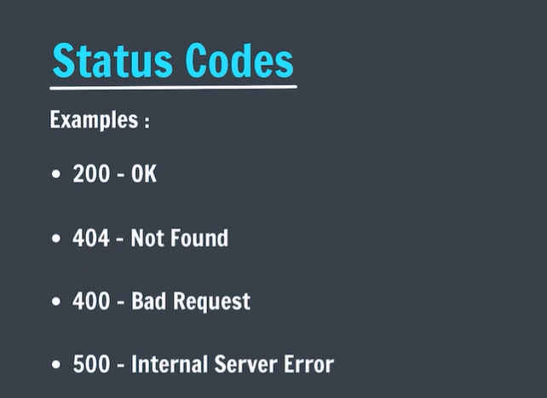**

In web development, an endpoint is a web address that allows clients to access a web service.

An endpoint is a combination of a URL and an HTTP method. The HTTP method defines the type of operation supported by that endpoint. For example, /users represents a collection of users in an API.

An [API](https://blog.hubspot.com/website/application-programming-interface-api?hubs_content=blog.hubspot.com/website/api-endpoint&hubs_content-cta=API), short for application programming interface, is a series of rules allowing an application to share its data with outside developers. In the plainest terms, an API enables you to take “their stuff” and make it work with “your stuff.” Their stuff, in this case, is located at the **API endpoint.**

**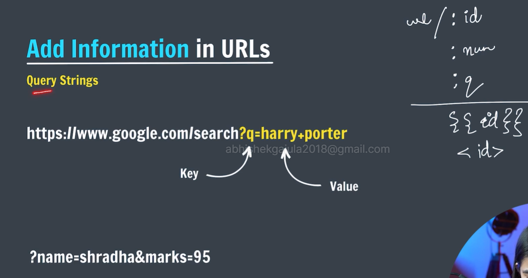**

**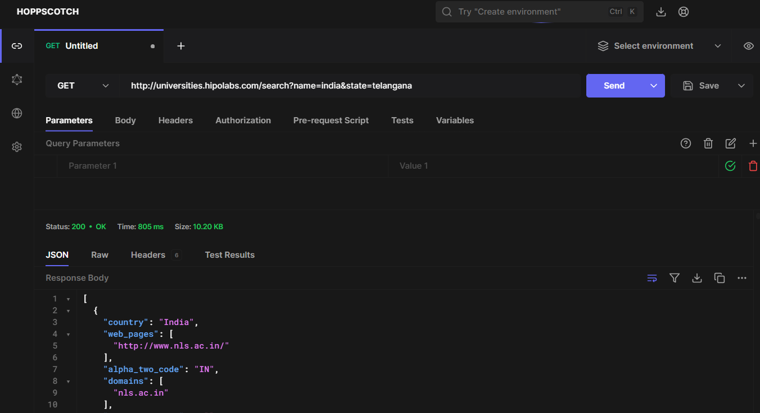**

**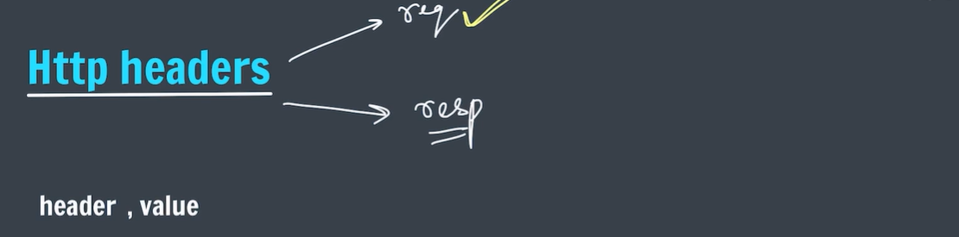**

**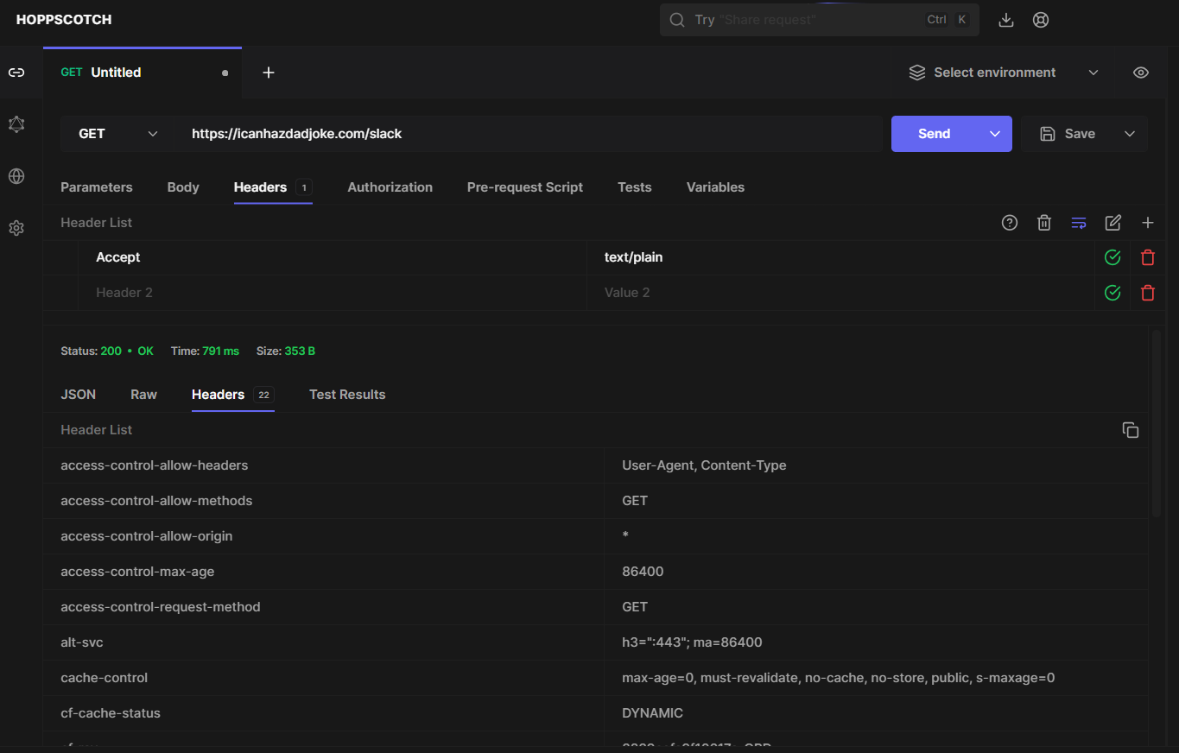**

# fetch API in JavaScript with Examples

**The JavaScript fetch() method** is used to **fetch resources from a server**. It returns a Promise that resolves to the Response object representing the response to the request.

The fetch method can also make HTTP requests- GET request (to get data) and POST request (to post data). Fetch also integrates advanced HTTP concepts such as **CORS** and other extensions to HTTP.

**Syntax:**

fetch('url') // api for the get request  
 .then(response => response.json())  
 .then(data => console.log(data));

**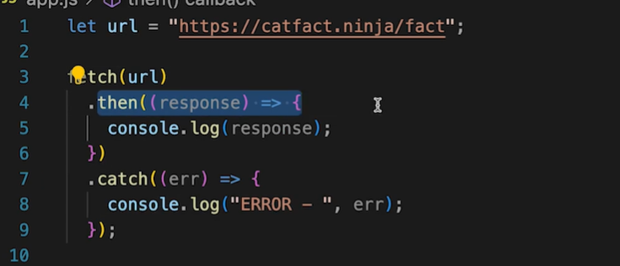**

* **Fetch will return promise and response as promise result if the fetch operation is success if not it will return err to catch block.**
* **In then block the response will print the response which is returned from the url but we cant read it.**
* **To access the actual data in the response we should use res.json() which also returns promise and object as promise result.**
* **From the given object we access the data in the then block.**

**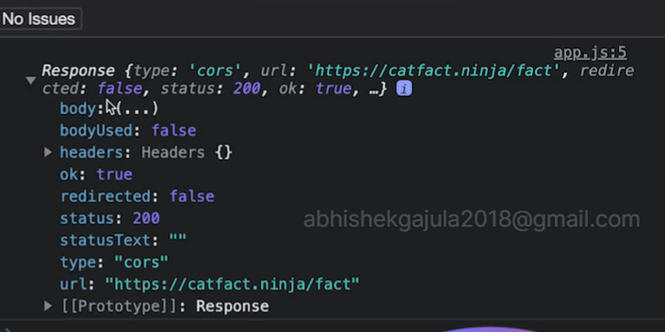**

**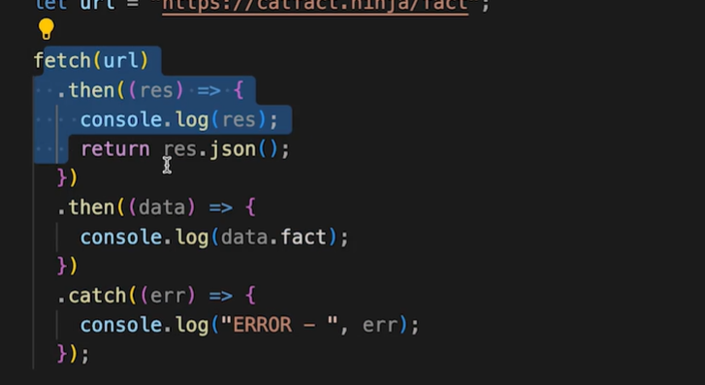**

**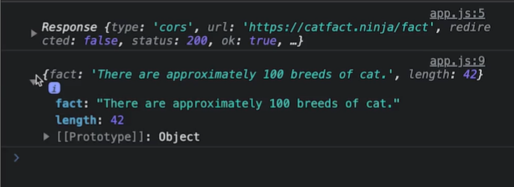**

* **Res.json() is used to extract the information from the respose.**
* **Above program using async and await.**

**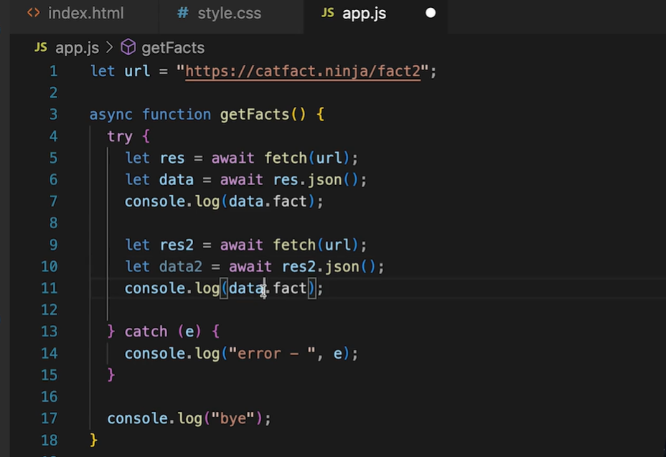**

# Axios in js:

* To axios in js we should use cdn link in our file

<script src="https://cdn.jsdelivr.net/npm/axios@1.6.7/dist/axios.min.js"></script>

* Axios is the shorthand of fetch function.

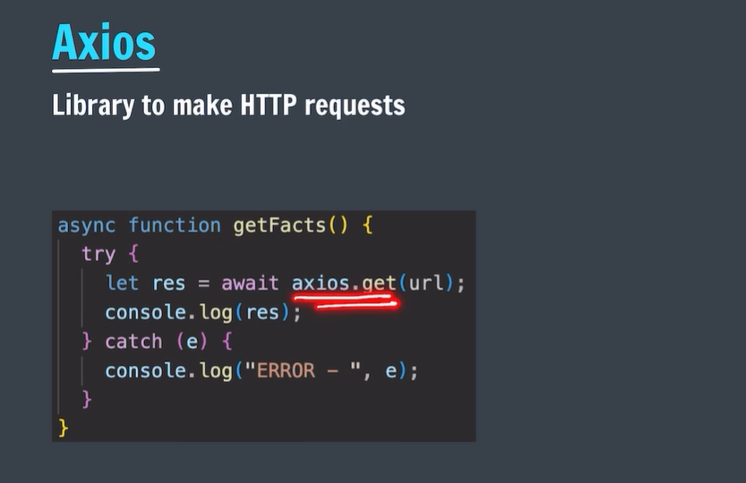

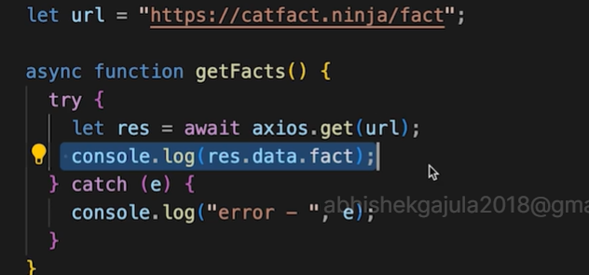

* An example with a axios and cat api.

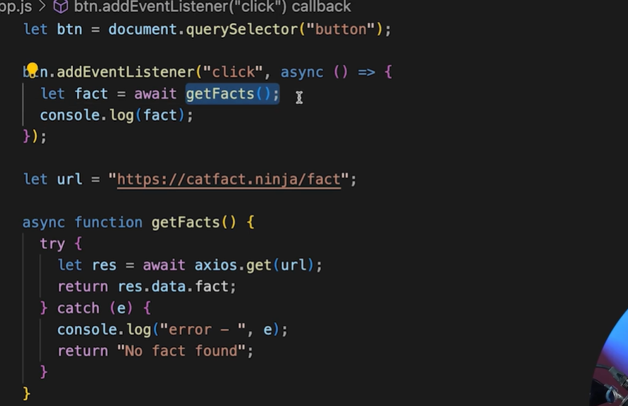

* Note: use limited api calls.

# Passing arguments along with url:

* To pass the header we have to create an object with header as key.

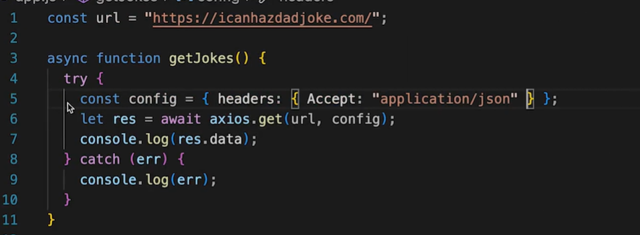

* In the above code header is itself a object and the information relate to headers are paced as key value pairs.
* let url="http://universities.hipolabs.com/search?name=";
* let btn=document.querySelector("button");
* let ul=document.querySelector("ul");
* btn.addEventListener("click",async ()=>{
* let country=document.querySelector("input").value;
* let colleges= await getColleges(country);
* addelments(colleges);
* });
* function addelments(colleges){
* for(item of colleges){
* let li= document.createElement("li");
* li.textContent=item.name;
* ul.append(li);
* }


* }
* async function  getColleges(country)
* {
* try{
* let res = await axios.get(url+country);
* console.log(res);
* return res.data;
* }
* catch(e){
* console.log("error :",e);
* }
* }

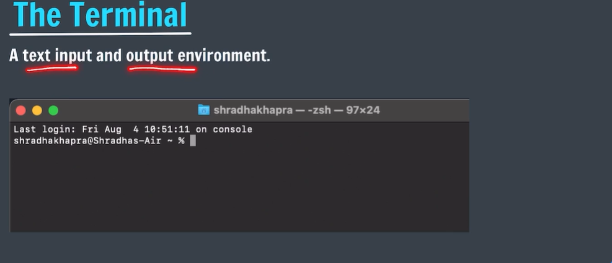

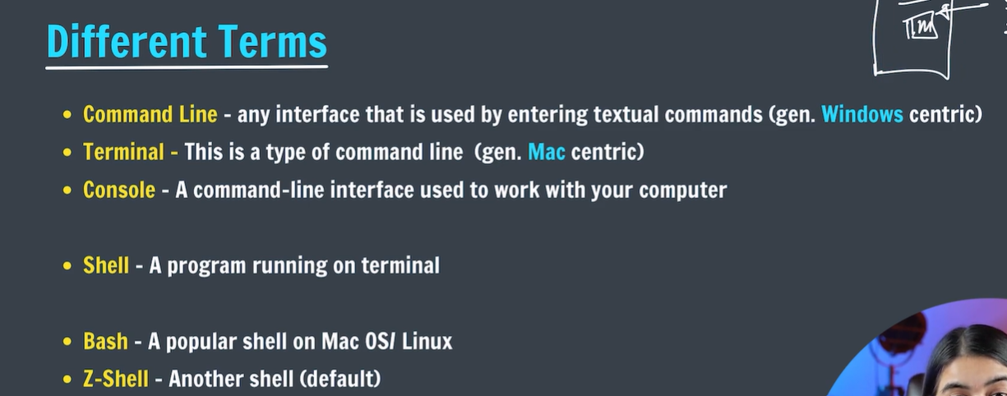

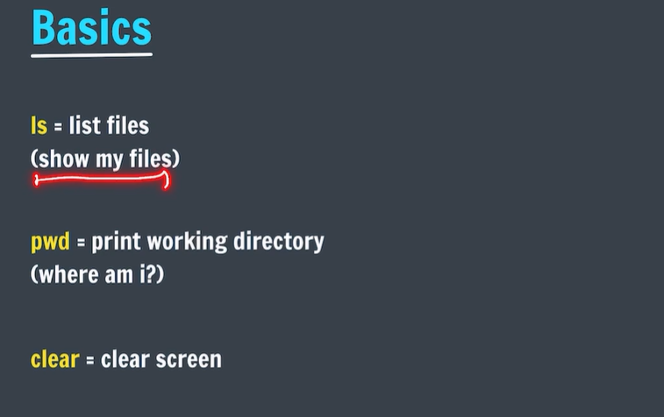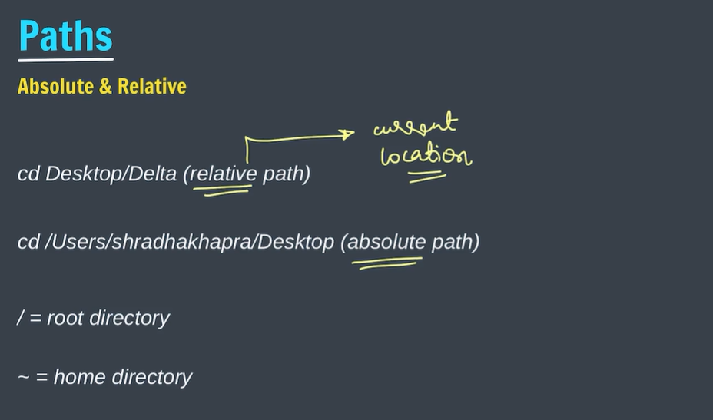

* Relative path will be different from different places.it starts with names.
* Absolute paths start with ‘/’ and it same from different places.

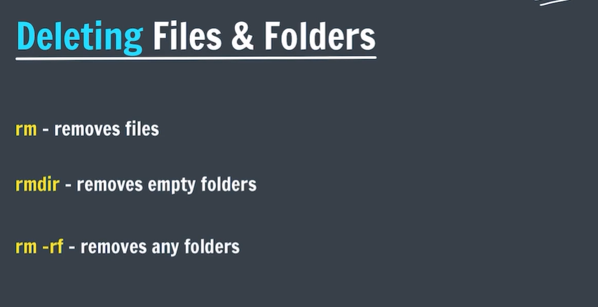

* Terminal has a special power that the which was removed using terminal can not be recycled.
* Rmdir is able to delete only the empty folders.
* Rm -rf removes any type folders.

## Git and git hub:

## 

## 

## 

## 

* In place of global we can use local and system.
* Mostly we global so that entire process in using git we should only use on username and email.
* We see the details by the command git config –list
* We can use the ‘q’ to quit any particular task in the command line.

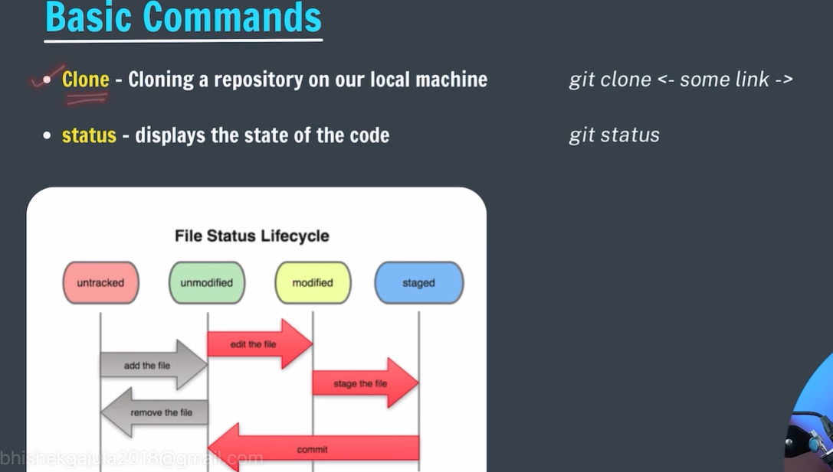

* IF we add new file in the repo that will be considered as untracked.
* An modified means the files which are already there in commited repo.
* If file modified is changed that can be considered as modified file.
* Clone used when we want the online repo to our current working system just like downloading the repo to our own offline git.

C:\Users\user>git clone https://github.com/AGabhishekgajula/MYFIRSTREPO.git

Cloning into 'MYFIRSTREPO'...

remote: Enumerating objects: 3, done.

remote: Counting objects: 100% (3/3), done.

remote: Compressing objects: 100% (2/2), done.

remote: Total 3 (delta 0), reused 3 (delta 0), pack-reused 0

Receiving objects: 100% (3/3), done.

* Some hidden files will be there when we clone the repository to our system and .git file we there for every repo in git.

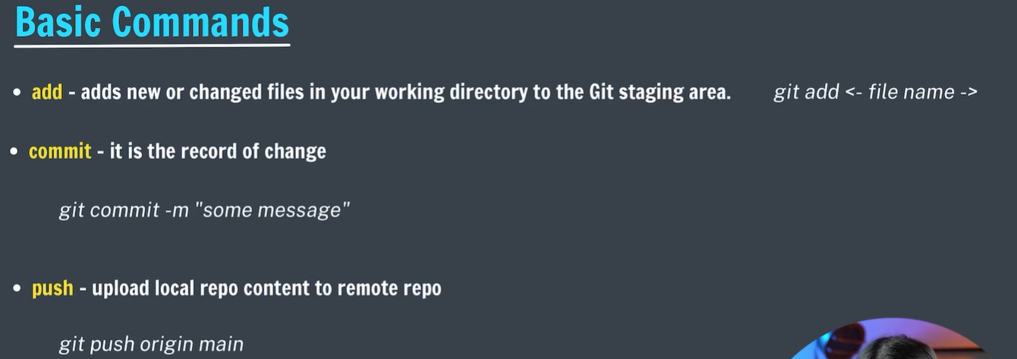

* TO add all the files at a time we can use ‘git add .’

